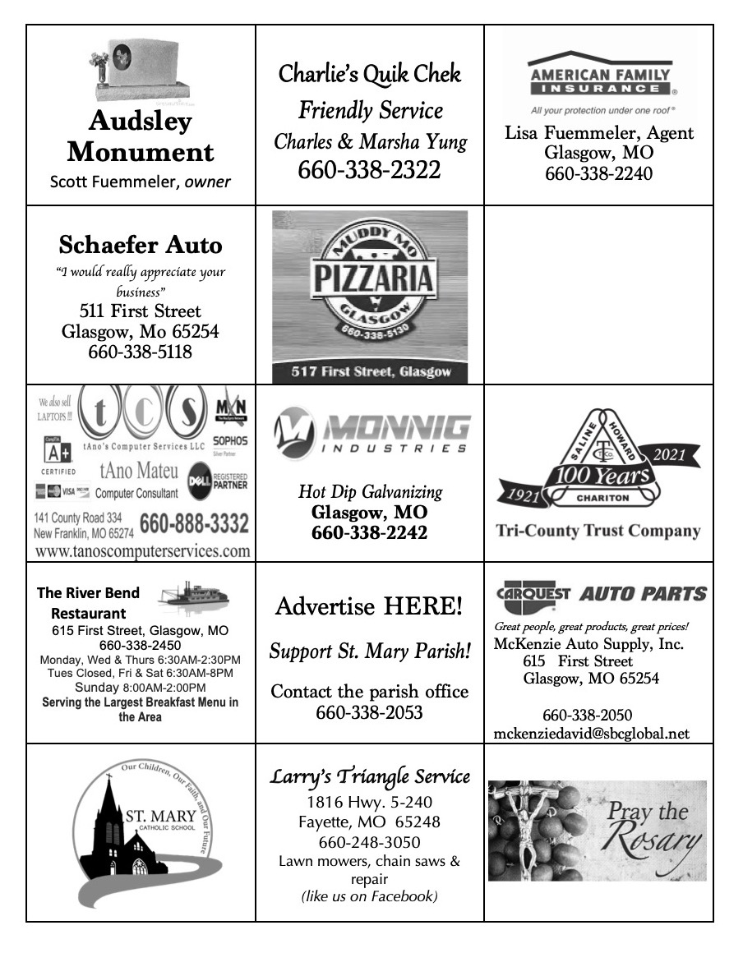
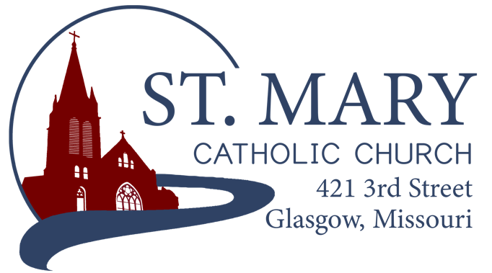
Mission Statement
We, the members of St Mary Parish, profess, practice, and proclaim our faith in Jesus Christ through word, sacraments, education and service.

EMAIL: parishoffice@stmarysglasgow.org
WEBSITE: www.glasgowstmary.com
FACEBOOK: St. Mary Church, Glasgow, MO

St. Mary Parish Office …………… 660-338-2053
St. Mary School Office …………...…… 660-338-2258

Parochial Administrator .….…… Fr. Joshua Duncan
School Principal …..…….……… Mr. Kent J. Monnig
Parish Bookkeeper/Secretary…. Wanda Fuemmeler

St. Mary Confessions:
Saturdays 4:00 – 5:15 pm

St. Mary Parish Office Hours:
Mon., Tues., Thurs.: 8 a.m. to 3 p.m.

St. Joseph Parish, Fayette – Schedule
Tuesday ……………. Mass 6:00 PM
Confessions 5:15 to 5:45 PM
Sundays……..……… Mass 8:30 AM
Confessions 7:45 to 8:15 AM
ST. MARY HOLY MASS SCHEDULE
Sun Oct 31  10:00 am | People of St. Mary & St Joseph Parish
Mon Nov 1  8:15 am | Poor Souls in purgatory
Tues Nov 2  8:15 am | For the deceased members of St Mary Parish
Tues Nov 2  (6:00 pm) | S.J. FAYETTE MASS
Wed Nov. 3  8:15 am | Cardinal Burke
Thurs Nov 4  8:15 am | Suzy Himmelberg†
Fri Nov 5  8:15 am | Gordon Glidden†
Sat Nov 6  5:30 pm | Marian Sellmeyer†
Sun Nov. 7  10:00 am | People of St. Mary & St Joseph Parish

St. Mary Parish Tithing Stewardship
Oct 3, 2021 $12,129.00
Oct 10, 2021 $5,593.00
Oct 17, 2021 $3,943.00
Total direct deposits
Total for month $21,665.00
Offertory budget goal / month $48,076.92
Weekly goal $12,019.23
(Under) for three weeks ($14,392.69)
Offertory Goal Year-to-date $216,346.14
Offertory year-to-date $152,570.89
(Under) Budget year-to-date ($63,775.25)
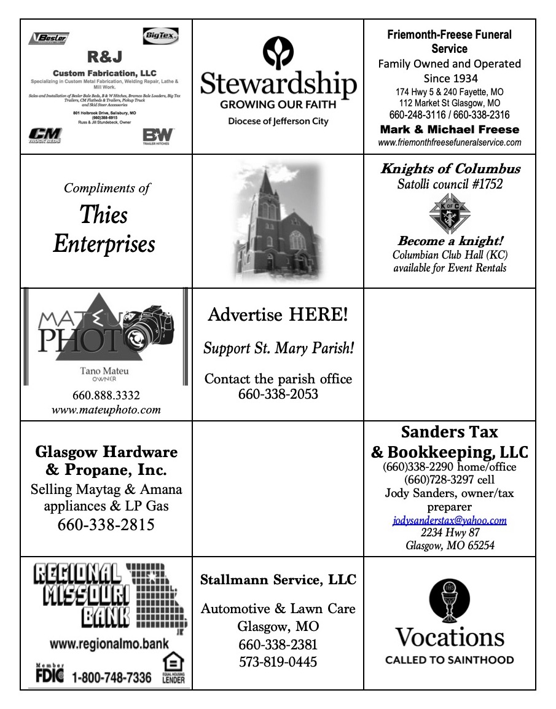
STEWARDSHIP – PARISH MINISTRIES
Sat. Nov 6  Rosary  Host Team  Lector  EO Ministers  Choir  Servers  Sun. Nov. 7  Rosary  Host Team  Lector  EO Ministers  Choir  Servers | 5:30 PM  Jamie Thies  Andy, Lindsey & Hudson Kallmeyer, Joe Morris  Erin Witte  Natalie Monnig  Anna McBride (loft)  Cecilia’s Voice  Evan & Ethan Thies  10:00 AM  Carol Wolz  Barry & Julie Fuemmeler  Cash & Chad Westhues  Sally Fuemmeler  Jenny Westhues  Gary Fuemmeler (loft)  Rise Up & Rejoice  Jaden DeMint  Addison Barringhaus
PLEASE PRAY FOR THE SICK
Ella Marie Wilson | Jason Monnig
Cindy Wilson Hall | Florence Weber
Dena Fitzgerald | Byron Stallo
Nursing Home Residents | All Military personnel and their families
Layla Johnson | Sam Audsley
Nina Bell Schafer | All Shut Ins
Suzanne Freese | Tony Monnig
Sister Jania Keogh | Greg Larm
Betty King | John Murphy
Tony Holt | Mary McCoy
Crystal Aholt | Mary Kay Noll
Father Paul Hartley | Gwen Brand
Sophia Friedrich | Lucille Vose
Dorothy Colvin | Margie Lewis
Wilma Christensen | Daniel Stallman
Blake Manken | Doris Gibbs
Cindy Crowley | Rhonda Hammons
Stacy Senor | Kevin Perry
Trish Lewis | Chance Lackland
Jim Aholt | Sheila Sellmeyer
Joe Fuemmeler | Will Beaman
Daniel Enyeart Michele Aholt
Gary Stallman
St. Mary Parish Capital Campaign
Totals as of October 12, 2021
Pledged - $501,750.49
Goal - $500,000.00
Pledges received - $421,973.95
Yet to Receive - $79,776.54
Thank you!! Your generous support helps us to move forward to keep improving our campus.

       

Bishop McKnight’s November prayer intention for our Local Church is: “For a deeper spirituality of stewardship among all the baptized: That from our gratitude for God’s many blessings we may offer our personal gifts & talents in service to the evangelizing mission of the Church.”

       

PARISH FALL DINNER UPDATES
-- Watch for parish letters and worker cards to come in the mail this week!
-- If you don't receive a worker card and want to work, please contact Jenna Lee or a committee member.
-- Thank you to all who have already signed up to donate items for the Fall Dinner! We are still really short on pies and homemade breads/rolls. Please consider helping out with this.
-- All volunteers are being asked to complete the Virtus Program for the diocese. Please see the information with worker cards for instructions.
-- This year coleslaw will be optional on all orders. Bottled water and tea will be available at time of purchase--for drive-thru only.
-- Pre-orders for in-town deliveries need to be made by Nov. 7th. Please contact Kathleen Thies to place your orders: 338-2409.

       

1st Friday Adoration – THIS FRIDAY NOVEMBER 5 Exposition following Mass, with Benediction at 2:30 PM
MASS SCHEDULE UPDATES
- November 1st, All Saints Day, is a Holy Day, but the US Bishop’s have dispensed from the “Obligation” since it falls on a Monday. We will have Holy Mass at 8:15 AM at St. Mary that morning.
- November 2nd, All Souls Day, we will have Holy Mass at 8:15 AM, followed by the customary procession to the Cemetary. There is also a 6 PM Mass at St. Joseph, Fayette that evening.

       

FALL 2021 CONFIRMATION
Confirmation for our 7th Grade School and CCD kids is rapidly approaching. Information regarding the ceremony was sent home with the candidates. A few things to take note of:
- Retreat: Sunday, November 7th, 12noon to 5 PM at St. Joseph, Fayette in the Parish Hall.
- Rehearsal: following the retreat in St. Joseph Church
- Dress/Other notes: See the sheet that was sent home.
Any questions, please contact Fr. Duncan – jduncan@diojeffcity.org

       

WORD AMONG US BOOKLETS
The November Issues of the Word Among Us Daily Readings & Meditation booklets are available to you in the back of Church! Please take a copy to assist you in your daily prayer life! They are free of charge for these few months, but donations will help us continue to provide these booklets in the future.

       
CHRISTMAS DECORATIONS
We are attempting to restore an outdoor nativity set and updating Christmas decorations for the interior of the church. If anyone would like to donate for this purpose, please drop your donation into a marked envelope and place it in the offering basket. Any assistance would be appreciated.

**SAFE ENVIRONMENT
(VIRTUS) COMPLIANCE**

All Parishioners in every Parish in the Diocese of Jefferson City, at the direction of the Bishop, are required to have the necessary Safe Environment training to be compliant with the Dallas Charter enacted by the USCCB in 2002.

WHO is this for?
- ALL Employees of the Parish/School.
- ALL Parents of children enrolled in our Parish’s Catholic School.
- ALL Parish Volunteers (Lectors, EMHC, Musicians, Fall Dinner, etc.)

WHAT does it require?
- An online Account, registered through www.virtusonline.org
- IF you are brand new to the VIRTUS website, you have the option to attend training IN-PERSON or train through the ONLINE portal. If you elect to train in person, you must set up an online account and sign up for the in-person session you wish to attend. If you need help with this, please contact the Parish Office for an instruction sheet or contact the Diocesan Chancery (573.635.9127).
- IF you already have a VIRTUS account (some parishioners do from 2003 onward), but are inactive, lost your password, aren’t sure about login information, or aren’t sure about what you need to do to “get current” – please contact the Diocesan Chancery (573.635.9127) and ask the receptionist for “help with my VIRTUS account”.
- IF you are NOT an employee, you only need to go through the training once, complete the background check information, and read the Code of Conduct – and you are good for forever! (As long as the diocese is using VIRTUS).
  - There are no “ongoing bulletins” to mess with. It’s a one-and-done.
- IF you ARE an employee, you only need to keep current on the assigned trainings once every couple of years. The monthly bulletins are optional.

IN-PERSON TRAINING OPTIONS
(must register online to attend)
- Sunday, November 7; 1:00 PM – at St. Mary, Glasgow in the School Cafeteria. (~2 hours)

       

ST. MARY SCHOOL NEWS

Students will have Mass on Monday, Tuesday, and Wednesday next week. Monday, November 1st; will be for ALL SAINTS’ DAY, with the 6th graders doing the ministries, Tuesday, November 2nd; ALL SOULS’ DAY, with 5th graders as ministers. After mass on Tuesday, (weather permitting) the whole school will walk to the cemetery where Father Duncan will say a blessing. Students will have about 10 minutes to walk around the cemetery, some may want to put flowers on the graves of loved ones. Wednesday, November, 3rd will be a normal school Mass for the week, with our 1st graders doing the ministries for the 1st time this year. We do not have Mass on Friday, November 5th, as we are out of school that day for Professional Development. We will do a student collection on Wednesday, November 3rd.
November 10th- Veterans Day Program/ CHADS presentation for 5-8 graders
November 15th- Day of school for students/approved at Advisory Board
November 19th-Flu Vaccinations for those that signed up for them
SAVE THE DATE—Christmas Program for St. Mary School is Sunday, December 5th, at 4 PM, in the church.
Donations to Benefit the School
St. Mary School would like to thank all that collect milk caps, ink cartridges, and best choice for the school. We recently received a check for $120 from Best Choice. Thanks to Julie Monnig for processing these for the school. We also want to acknowledge the $500 from D of I of Boonville/Glasgow, where 8 of our ladies joined their group since the one at St. Mary Church disbanded earlier in the year. George Brucks, Jr. has made a generous donation again this year to benefit the school, students, and teachers. We also received $1000 donation from Affiliated Farm Management. Some of the money from these donations will cover the cost of implementing our new Accelerated Reading Program, that will be available in 2022.

