WELCOME, FATHER JOSHUA DUNCAN TO ST. MARY’S PARISH
Catholic School Week
January 31-February 5, 2021
The tradition to gather together with St. Mary students and families is celebrated with Mass at the start and end of this blessed, fun filled week. Father Joshua Duncan talked to the students (photo to left) at the end of Catholic school week about how we are here for each other, YOU are not ALONE. We are here to support, be kind, help, and love each other. Be that saint God wants you to be and that will lead you to heaven.

ST. MARY SCHOOL-
OUR CHILDREN, OUR FAITH,
OUR FUTURE

St. Mary's School is committed to educating the whole child. St. Mary's School provides opportunities for spiritual, moral, intellectual, and physical growth of each student in a loving, Catholic environment. Students are encouraged to share and to serve within the school, church, and community while realizing their own full potential.

  - ST. MARY PARISH GLASGOW MISSOURI – ON THE MOVE 2021

SMS ALUMNI CONNECTION

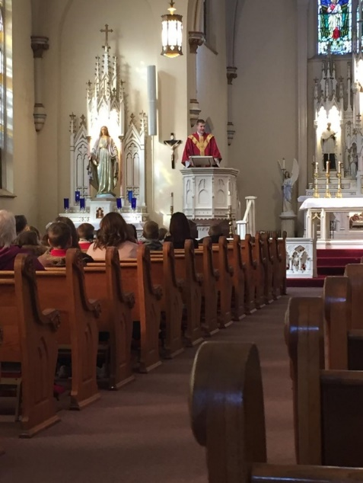

Hello! I know this has not been the usual time for transitions, moving, and getting used to a new priest, but I sincerely thank all of you in welcoming me to your Parish. I’m excited and honored to be here. I have always heard good things about St. Mary’s in Glasgow, but this is the first real chance to experience all the great things we have going on. This first month here has taught me that we are indeed very blessed, and I would like to do all that I can to keep the positive momentum moving forward.
I am a firm believer in Catholic Schools, as I have been fortunate enough to attend Catholic K-8

(Immaculate Conception, Jefferson City) and Catholic High School (Helias Catholic High School). My family has been lifelong parishioners of Immaculate Conception in Jefferson City, which is where I
grew up. I have three younger siblings, all within 5 years of me, and 3 nephews and 1 soon-to-be niece. I also have a 4 month old Chocolate Lab, Ollie that I was fortunate enough to get around the first of November when I was at Our Lady of Lourdes in Columbia. He has adjusted well with the move and loves it here!
We have a lot of exciting things happening in the school with Catholic Schools Week, celebrating the Sacrament of Confirmation with our 7th/8th (and 9th) Grades, as well as trying to build on our new partnership with St. Joseph in Fayette. I’m very grateful to Mr. Kent Monnig for his leadership as well as for all of our hard working and dedicated Faculty and Staff. Please keep all of our school community in your prayers. We wouldn’t be the great school we are if it weren’t for their tireless effort and your support! May God bless each of your families and keep you safe.
– Fr. Duncan

CATHOLIC SCHOOL WEEK 2021
Kent Monnig, Principal
With COVID protocols in place, some of our traditional Catholic Schools Week activities were altered. The school hosted a penny war and food drive to benefit our local food pantry. We also had a raffle to benefit the school’s door and floor fund. We are trying to raise funds to update the seven fire escape doors in the school to

something with safety glass and better R-value. Carpet in our middle floor classrooms are also due for replacement. We rely on fundraisers, donations, and memorials left to the school to address items on our wish list. Themes for the week included: Community Day, Parent Day, Nations Day, Student Day, and Grandparent Appreciation. The students got to enjoy special dress opportunities away from the typical

uniforms. As part of our student days, they also went bowling, thanks to our local Knights of Columbus. This year parents did a special breakfast for the kids as well on Student Day. It is great to celebrate the fact that we can offer students in the Glasgow community and surrounding areas a Catholic School experience. We thank our ancestors, alumni, parents and parishioners for making this possible.
SELF STUDY & SCHOOL IMPROVEMENTS
Despite COVID, St. Mary School was able to complete our Self-Study process this year. Major strengths identified during the on-site visit were the historical integrity and character of our older building, the Catholic identity being highly evident throughout the school, and the academic rigor in place to ensure student success.
Key focus areas to improve St. Mary School were to work closely with the Finance Council and School Foundation, to continue to push for technology upgrades and integration of these updates into instruction, and to provide more funding for professional development for the faculty and staff.
We have 36 key recommendations from the Self-Study to integrate into our 5-year plan of improvement. This whole process is a great way to push us to continue to improve our school.
Some improvements on the recommendation list have already happened due to generous donors giving money directly to the school both last Christmas and again this year. We now have a principal office, computer lab, and our 2nd grade converted back to its original size. We also have new lighting throughout the building and 16 new windows were installed this past summer. Thanks to all that made this work possible
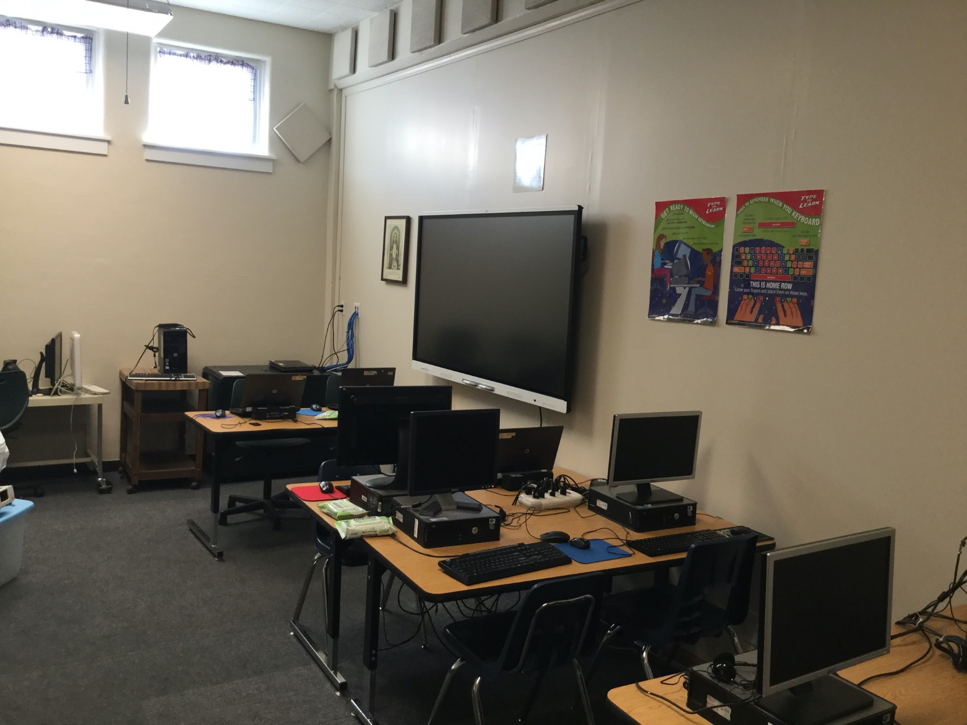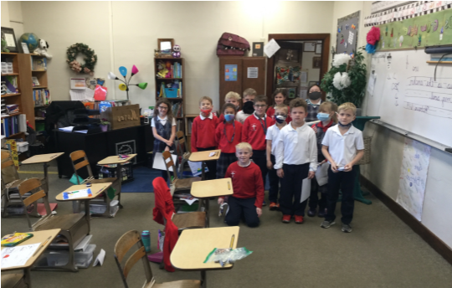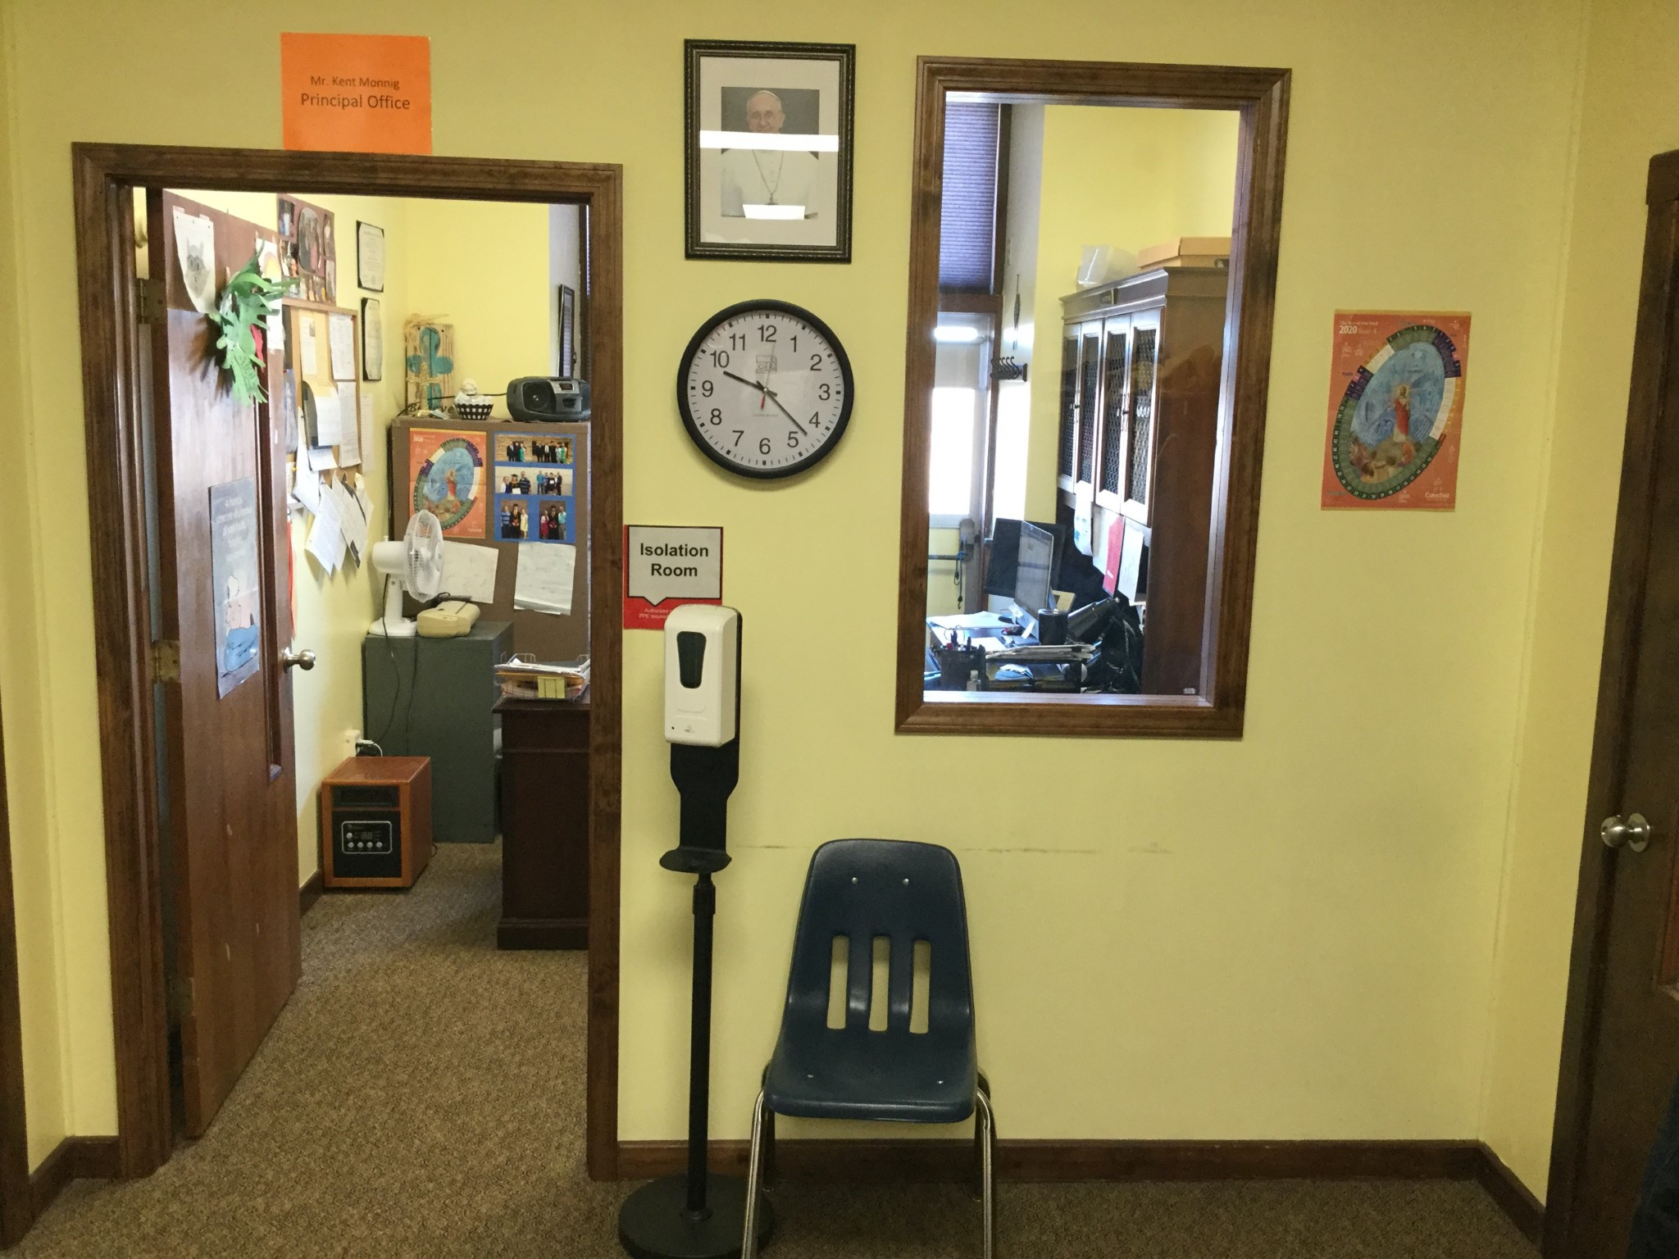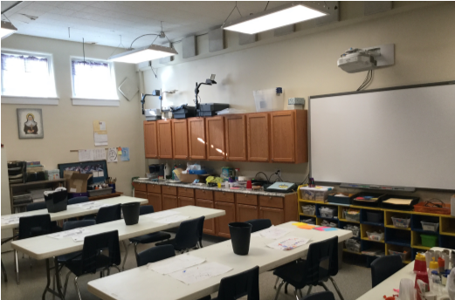

HOW COVID HAS CHANGED OUR DAILY SCHOOL LIFE? By Emma Westhues: School has changed a lot since last year. We have had to bring our own water bottles and wear masks in the hallways. Our classrooms can’t go to church together either. The thing I miss most about regular school is getting to play with my friends in other classes at recess. All the kids don’t get to play with their friends in other classes. By Cash Westhues: Going to school is different with CoVid. We can only play with our class at recess. Only three classes go to lunch at the same time and we always have to wear masks in public places. I wish things would go back to normal.
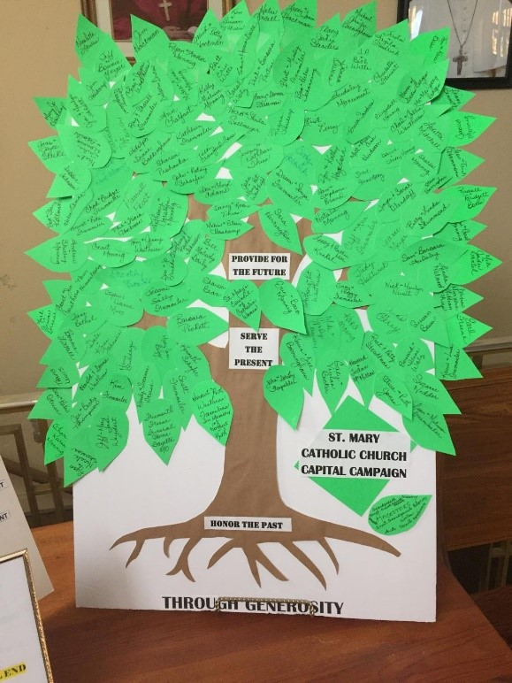
BECAUSE OF YOUR GENEROSITY, YOU HAVE MADE A DIFFERENCE! THIS TREE STARTED AS A BARE TRUNK, NOW IT IS FULL OF LEAVES OF THOSE PLEDGED, DONATED TIME, SUPPLIES, AND LABOR TO THE ST. MARY CAPITAL CAMPAIGN. MANY BLESSINGS & THANK YOU

WORK COMPLETED OR WORK IN PROGRESS
New steps, ramp, and railing. A water heater was installed in the church basement and coil was installed in the steps and ramps to help keep the ice and snow melted during the winter months.
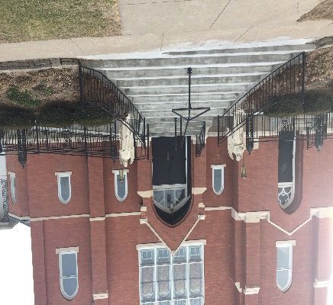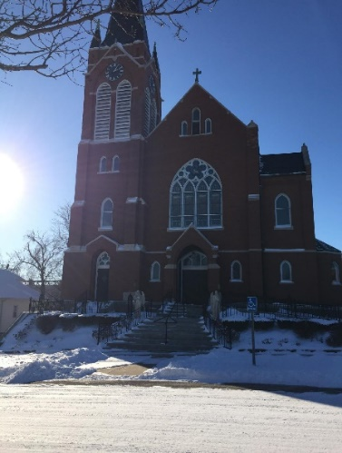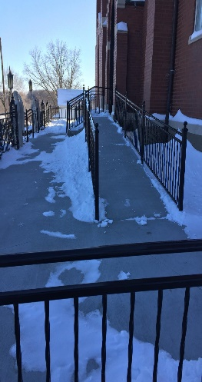
THANK YOU FOR YOUR SUPPORT
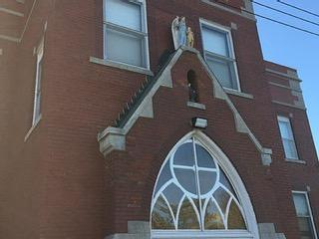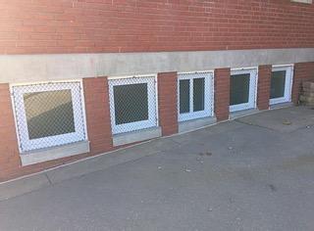
St. Mary School projects completed include the tuck pointing, 16 new lower level windows, LED lighting in school, and all of the self-study improvements. Other repairs pending are new doors and windows and indoor sewer line repairs.

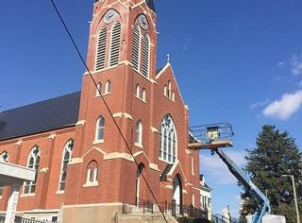
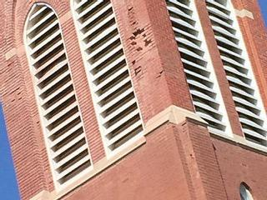
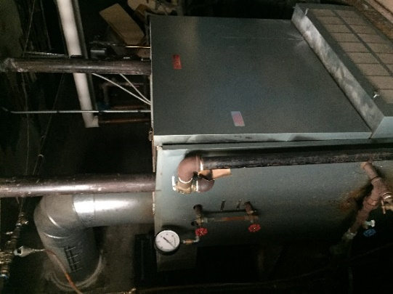
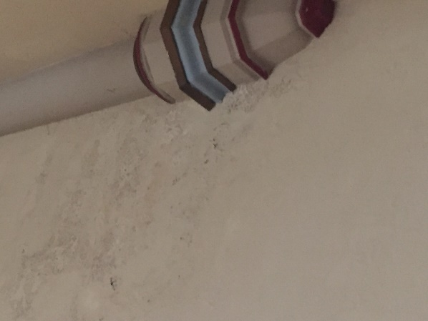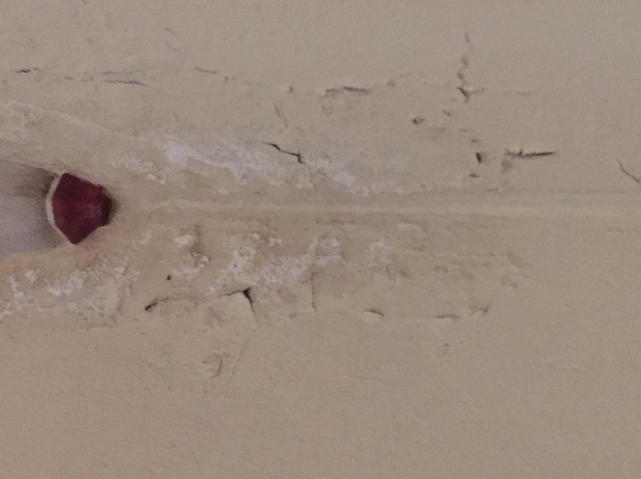

The church tower tuck pointing is in progress. In the near future, the entire church will be tuck pointed. Sacristy and Altar area repairs are also needed. A new boiler will be installed this spring. If funding is available, another goal is to renovate the church basement and restrooms to accommodate: families, young mothers with their children, handicap accessible, gatherings, classes, children’s liturgy, meetings, quilting among many other things. (See photos on next page)

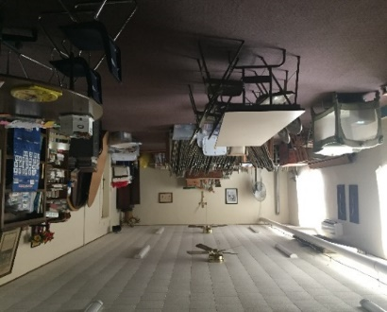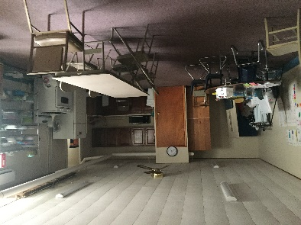
ST. MARY’S CHURCH BASEMENT
A PLACE WHERE LEARNING, FELLOWSHIP, PRAYING, TALENTS, AND GATHERINGS HAPPEN
Work in the process for St. Mary’s Rectory include new floor and carpet installation, repair of second floor ceiling, window replacements and a new fresh coat of interior wall paint. St. Mary’s Rectory is a welcoming place for all who come to visit and enter.
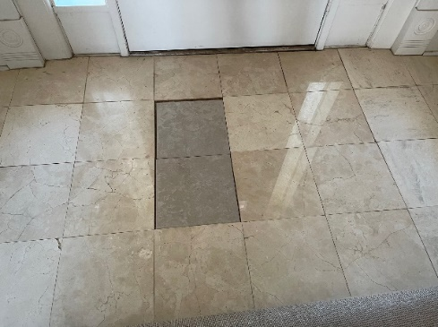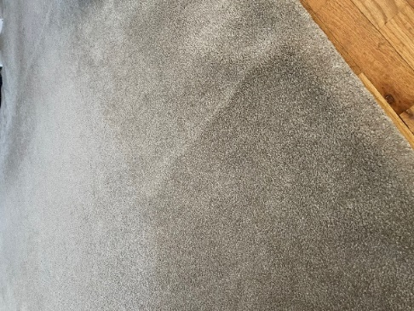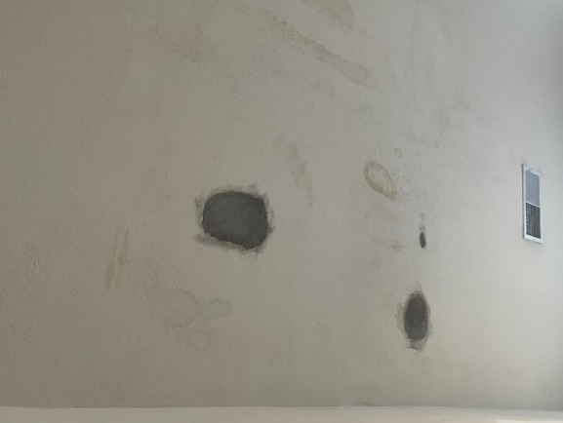

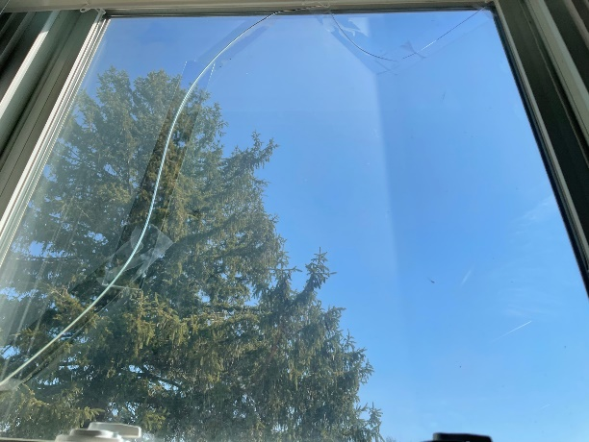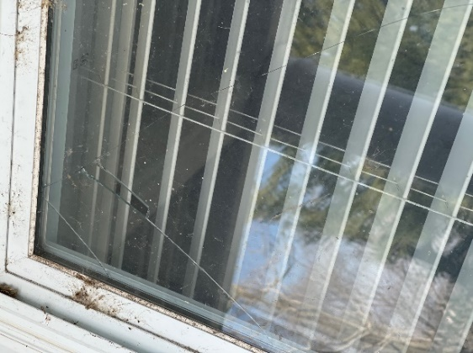

Ground repairs include construction of concrete stone wall north of rectory, gravel and blading to driveway to garage at the same time north wall is being repaired, new concrete wall, fencing, and asphalt to divert the water off the upper parking lot/playground.
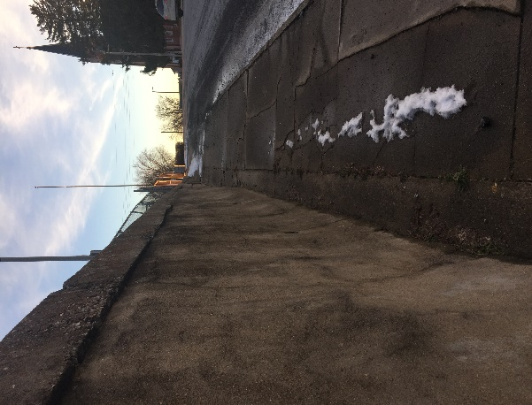
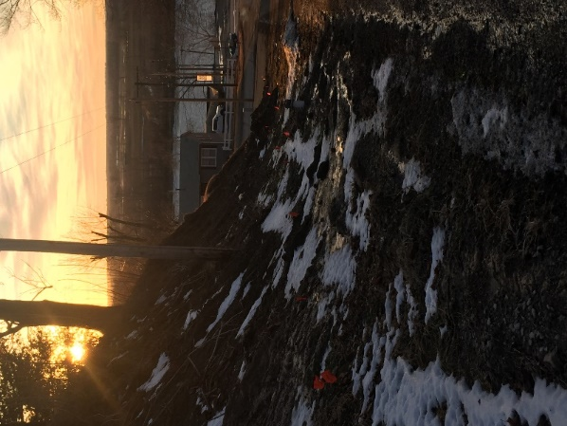
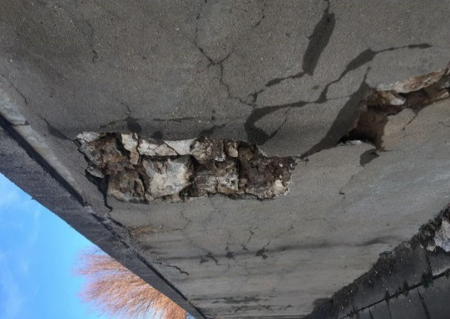

LET US WELCOME YOU, LET US PROCLAIM GOD’S GOOD NEWS TO YOU, LET US SING WITH YOU, ST. MARY PARISH IS BLESSED WITH AN ABUNDANCE OF TALENTS, TREASURES, HIDDEN FIGURES, FAMILIES, FRIENDS, YOUTH AND LONGTIME PARISHIONERS WHO ARE ALWAYS THERE TO SUPPORT AND BUILD A STRONG FOUNDATION OF FAITH
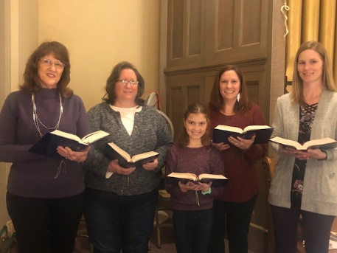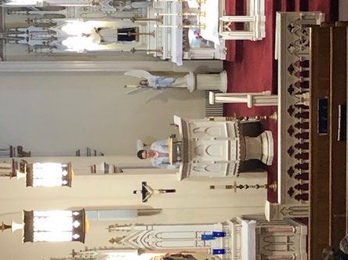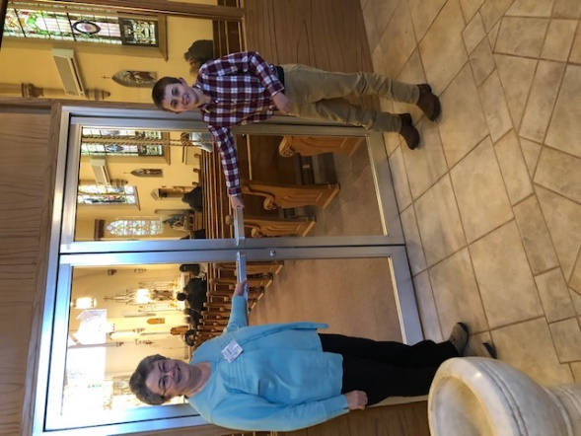
TIME – TALENTS – TREASURES BY KATHY MONNIG, LITURIGICAL MINISTRIES
“There are different kinds of spiritual gifts, but the same Spirit; there are different forms of service, but the same Lord; there are different workings, but the same God who produces all of them in everyone. To each individual the manifestation of the Spirit is given for some benefit.”1 Corinthians 12:4-7
Please take a moment and ask yourself this question, why do I go to Mass? Is it obligation, fulfillment or guilt reduction? Is it a custom and habit, or comfort and care? Is it the expectation of others, or a good example for my kids? Is it to look good in front of my family, or because someone is making me? Is the reason you are here just about internal consumption? If you’re honest with yourself and you’ve answered yes to any of these questions, then please, consider ways to make it mean more.
Each of us have gifts that are individual to us. This is such a divine blessing that allows our Parish to be well rounded and capable of doing so much to help spread God’s message. Now, more than ever, we need to strengthen our Parish so we can help bring peace and joy to a world full of chaos. This can only be done through the intercession of the Holy Spirit. Small deeds and small sacrifices can have BIG impacts. Not only will you help enhance the lives of your Parish family, but to serve others, is to serve God. There are many ways you can do this and it is open to everyone, at any age.
Join us, we need you! Help us make our Parish more, our Mission reach further and HIS message heard. Please call or text Kathy Monnig at 660-728-2194. Thank you for your consideration!

CHURCH MANAGEMENT SYSTEM (BLACKBAUD CHURCH MANAGEMENT) - BY NICK MONNIG

The events over the last year have brought changes to many of our lives. They have also exposed areas of needed improvement as well. For our Parish, the last 12 months have brought to light our need for a virtual presence and a way to directly communicate with parishioners (past and present), alum, and those connected to St Mary Parish and School. Businesses, organizations, schools, churches, etc. have made a quick shift since March to drastically increase their virtual presence. At St. Mary’s Church, thanks to the generous donation from a parish family, we are making the giant leap to virtually integrate our Church lives/records. Rather than having multiple lists, spreadsheets, calendars, etc., we will incorporate everything into one Church Management System (Blackbaud Church Management). From the Church administration side, this allows us to keep everything in one place, and not have to chase down lists, remember to update, try to find contact information, etc. In a time like this, though, it also allows us to quickly communicate with the entire congregation. Thanks to the work of Marjorie Thies, we have an awesome website and Facebook page, but this system will allow more direct communication. It will also provide improved transparency. From the Mobile Mission App, you can view your tithing history, you can make a one-time or recurring gift with a credit or debit card, edit a recurring gift, or even communicate with a small group/Mass ministry group that you might be a part of. In today’s world, efficiency is everything and this system improves both the efficiency for the St. Mary’s Church Administration and for you.

In order to fully utilize this system, we have two requests from all of you:

- Complete the online form at this link: : https://diojeffcity.org/glasgow-stewardship-form/

- Please help us spread the word to complete this form. We want current parishioners, past parishioners, Alum of St. Mary’s School, etc. to complete it. Basically, anyone who currently has, or previously had an affiliation with St. Mary’s Church or School. It allows us to not only stay connected, but also to see where the foundation of St. Mary’s may have taken them in life.
Thanks for your assistance with this project

2021 CONFIRMATION CELEBRATION – MAY YOU SHINE EACH DAY THROUGH THE HOLY SPIRIT
Confirmation was celebrated on Tuesday, March 9th 2021 at St. Mary Church Glasgow
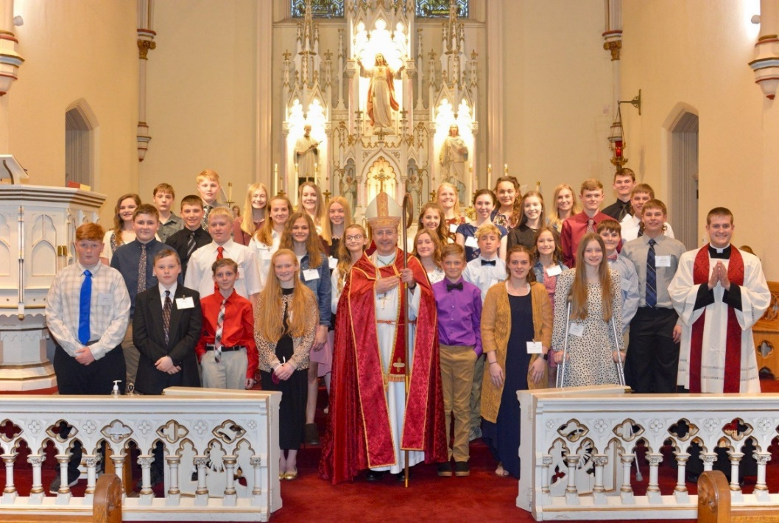

SMS ALUMNI CONNECTION-glasgowstmary.com. Please share this publication with family and friends. Spread the good news we have to share about St. Mary Parish – Come Back and See Us, ALL ARE WELCOME. Any comments, support, and prayers email virginiawesthues@gmail.com.
Thank You Jenny Westhues

ST. MARY PARISH GLASGOW MISSOURI – ON THE MOVE 2021
ST. MARY CHURCH
421 3RD STREET
GLASGOW, MO 65254

