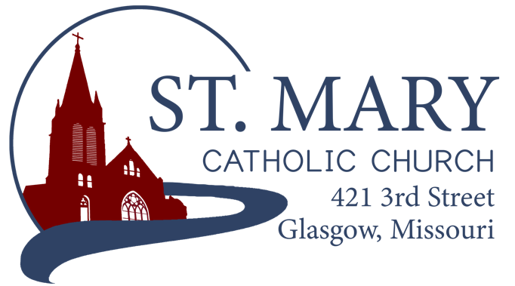

Mission Statement
We, the members of St Mary Parish, profess, practice, and proclaim our faith in Jesus Christ through word, sacraments, education and service.

EMAIL: parishoffice@stmarysglasgow.org
WEBSITE: www.glasgowstmary.com
FACEBOOK: St. Mary Church, Glasgow, MO

St. Mary Parish Office …………… 660-338-2053
St. Mary School Office …………...…… 660-338-2258

Parochial Administrator .….…… Fr. Joshua Duncan
School Principal …..…….……… Mr. Kent J. Monnig
Parish Bookkeeper/Secretary…. Wanda Fuemmeler

St. Mary Confessions:
Saturdays 4:00 – 5:15 pm

St. Mary Parish Office Hours:
Mon., Tues., Thurs.: 8 a.m. to 3 p.m.

St. Joseph Parish, Fayette – Schedule
Tuesday ……………. Mass 6:00 PM
Confessions 5:15 to 5:45 PM
Sundays……..……… Mass 8:30 AM
Confessions 7:45 to 8:15 AM
ST. MARY HOLY MASS SCHEDULE
Sun Jan 23  10:00 am | Harry Lewis Jr. †
Tues Jan. 25  (6:00 pm) | S.J. FAYETTE MASS
Wed. Jan. 26  8:15 am | Dianne Frye†
Thurs Jan 27  8:15 am | Lester & Mary Catherine Lackland†
Fri Jan 28  8:15 am | Debbie Garrotto†
Sat Jan 29  5:30 pm | Eugene & Mary Athlyn Fuemmeler†
Sun Jan 30  10:00 am | People of St Mary & St Joseph Parish
St. Mary Parish Tithing Stewardship
Jan. 2, 2022 $4,998.00
Jan. 9, 2022 $8,737.00
Jan. 16, 2022 $4,750.00
Jan. 23, 2022 $
Jan. 31, 2022 $
Total direct deposits $
Total for month $18,485.00

Offertory budget goal / month $48,076.92
Weekly goal $12,019.23
(Under) for three weeks ($17,572.69)

Offertory Goal Year-to-date $360,576.90
Offertory year-to-date $307,330.89
(Under) Budget year-to-date ($53,246.01)
STEWARDSHIP – PARISH MINISTRIES
Sat. Jan 29  Rosary  Host Team  Lector  EO Ministers  Choir  Servers  Sun. Jan 30  Rosary  Host Team  Lector  EO Ministers  Choir  Servers | 5:30 pm  Marjorie Thies  Nick & Megan Meyer Family  Nicholette Lewis  Herb Fuemmeler  Jim Hackman (loft)  Volunteers needed  Lillian Thies  Jaclyn Johnson  10:00 AM  Bill Daily  TBD  TBD  Kent Monnig  Ryan Monnig (loft)  St. Mary School  Cash Westhues  Christopher Schaefer
PLEASE PRAY FOR THE SICK
Ella Marie Wilson | Jason Monnig
Cindy Wilson Hall | Byron Stallo
Nursing Home  Residents | All Military personnel  And their families
Dena Fitzgerald | Sam Audsley
Layla Johnson | All Shut Ins
Nina Bell Schafer | Tony Monnig
Suzanne Freese | Greg Larm
Sister Jania Keogh | John Murphy
Betty King | Mary McCoy
Tony Holt | Mary Kay Noll
Crystal Aholt | Gwen Brand
Sophia Friedrich | Lucille Vose
Dorothy Colvin | Margie Lewis
Wilma Christensen | Daniel Stallman
Blake Manken | Doris Gibbs
Cindy Crowley | Rhonda Hammons
Trish Lewis | Kevin Perry
Joe Fuemmeler | Chance Lackland
Daniel Enyeart | Sheila Sellmeyer
Gary Stallman | Will Beaman
Karen Alden | Michele Aholt
Damian Barton Jerome Schaefer
Rita Fuemmeler

ST. MARY CAPITAL CAMPAIGN
Totals as of January 5, 2022
Pledged - $485,979.36
Goal - $500,000.00
Pledges received - $439,526.36
Yet to Receive - $46,453.00
Thank you!! Your generous support helps us to move forward to keep improving our campus.

       

2021-2022 CATHOLIC
STEWARDSHIP APPEAL (CSA)
Totals as of January 4, 2022
- Parish Goal = $13,260
- $ Received = $11,555 (87 % of goal)
- $ Committed = $13,275 (100% of goal)
Thank you to all who have given so far – if we reach our Parish goal, we will receive 10% of our goal back + 90% back of whatever we go over our goal as a rebate check from the diocese! As it stands, if all pledges are fulfilled by March 1, 2022, we will receive a rebate check for $1,373.50. Thank you!!

       
Bishop McKnight’s January prayer intention for our Local Church is: “As we begin a new year, may the opportunities for the grace to clearly recognize the dignity of life, education and ecumenism allow us to better support our brothers and sisters who need the warmth of Christ’s love and our compassion during this winter season.”
       

THANK YOU FROM FR. DUNCAN
Thank you all so very much for all the many cards, gifts, and wishes for a Blessed Christmas that I received as we celebrated the wonderful Feast of Our Lord’s Nativity. Thank you also for the many birthday cards and wishes! I am so grateful to be able to be here as your priest (now of 1 year here!). It is evident over this past year that you all continue to show me how wonderful St. Mary’s Parish and her members are. May God Bless you and your families!

KNIGHTS OF COLUMBUS DINNER
The Knights of Columbus will be hosting a free-of-charge pork steak dinner for the families and widows of the Knights on Saturday, February 5 after Mass at the Knights Hall. Knights with the last names starting with A-L are requested to bring a side dish; and M-Z a dessert.
       
CATHOLIC SCHOOLS WEEK BREAKFAST
Home and School is hosting a Catholic Schools week breakfast on Sunday, January 30 in the School Cafeteria. They will be serving from 8:00 AM to 12:00 PM – Pancakes, Biscuits and Gravy, Sausage, and Scrambled Eggs. It is a free will donation.
       
PARISH SMALL GROUP opportunity – open to everyone!
Grateful Living: The Joy of Stewardship
Our Baptism calls us to deepen our relationship with Christ & with all of God’s family. Therefore, our parish is joining others throughout the diocese to grow together in grateful living, in holiness, in fullness of life by participating in the parish process of small faith-sharing groups called Grateful Living: The Joy of Stewardship. These groups will begin to meet weekly around the beginning of Lent and last for about six weeks. The small Grateful Living faith-sharing groups will help us to deepen our understanding of this foundation of our faith & our response to God. Participating in a small group encourages us to grow with support of others. Watch for more information in coming weeks.
       

WORD AMONG US BOOKLETS
The February Issue of the Word Among Us Daily Readings & Meditation booklets are available to you in the back of Church! Please take a copy to assist you in your daily prayer life! They are free of charge, but donations will help us continue to provide these booklets in the future. With a Parish subscription, they are roughly $1.32 / booklet. We currently have enough donated to continue providing these through April 2022! Thank you!
       
INCLEMENT WEATHER
As we enter our Winter weather season, please exercise prudent judgment whenever we have poor weather conditions. We will still have Mass here at St. Mary Church even if school is called off due to weather. We would rather you be safe and exercise caution in treacherous conditions than risk your safety. As a general principle, “if it’s too treacherous to go to Mass that day, it’s too treacherous to venture out anywhere for that day.”
       

ST. MARY SCHOOL NEWS

Casey’s Rewards
Thanks to all that are taking the time to enter your phone number and use the app to benefit our school when you are at Casey’s. If you get gas or stop at Casey’s often, please consider using this program to benefit the school.

PRESCHOOL 22/23 PROJECT
It is not to late to get your child’s name in for wanting to be a candidate for a preschool at St. Mary School. We are looking at current students and 5 years out to make sure we have enough interest to support the program. Currently we are envisioning opening this up to both 3- and 4-year-old students. The program would be all day, with the option of only sending ½ day for those that want that type of day for their child. Preference will go towards 4 year olds and members of the parish, but the program would be open to all as long as we have room. Other details will be given as we move forward. Please don’t hesitate to call or seek out members working on this project if you have questions.

Change of Calendar/ Diocesan Changes that affect our candendar
March 18th, Regional PD Day in Moberly has been canceled and that will be replaced with a Diocesan PD Day at Helias on March 21st. (NO SCHOOL FOR KIDS) We will be out of school from April 14th – 20th for Easter break. Please call the office if you have any questions regarding these calendar changes.

CATHOLIC SCHOOLS WEEK 2022

Ongoing projects for the week:
FOOD DRIVE, PENNY WAR, & Raffle

Sunday, January 30th Kick-off Mass -Student led ministries and choir.
Home and School Breakfast- 8-12 school cafeteria

Monday, January 31st
Community Day-School will show appreciation to our businesses in town that do so much to support our school and parish.
*Students will get to wear their favorite pjs, slippers, and can sport crazy hair that day. Please bring tennis shoes for recess.

Tuesday, February 1st
Pastries for Parents - Parents, please plan to come to school between 7:15 & 8 and enjoy a pastry with your child.
Vocation Day classes will be putting together care packages to send to seminarians in our diocese and to the Sister of the Most Precious Blood in O’Fallon.
*Students will get to wear their favorite hoodie with their school uniform that day.

Wednesday, February 2nd
Nation Day- After mass, the student body will gather around the flagpole for the raising of the flags and to say the pledge of allegiance. We will also have a guest that will speak about their service to the country.
*Students may wear crazy socks to school, they are also encouraged to decorate a hat to show their patriotism, to be worn after church. These are to be patriotic, NOT POLITICAL. Anything deemed Political will be removed.

Thursday, February 3rd
PENNY WAR ENDS AT 9 A.M.!!!!!
*Student Day- Dress down day for students (School Appropriate) Please remember that we will be bowling and doing other active stations that afternoon when selecting what to wear that day. We will start our day with the Home and School Student Breakfast. We will start our station rotations that day by 11 AM. We will also include lunch this year in the rotation. An ice cream sundae snack is planned as part of the day as well. We could use a set of parents to volunteer at the bowling alley that afternoon to help with all the groups. Let the office know if you would like to help out that day. Thank you

Friday, February 4th (*Students in Uniform) Grandparent/ special guest Day
Grandparents/ Special Guest Mass at 10 A.M. We want grandparents or special guests that are comfortable attending a full church for Mass to join us to celebrate the close of Catholic Schools Week. For those not comfortable with attending Mass with a large group, are asked to plan to pick up their grandkids at 11 A.M. that day and plan a special afternoon with their grandkids. Students will have a small treat and welcoming note to share with their guests that day. We will do our raffle drawing and other prize items at 9 AM in the cafeteria. Students will be ready to be picked up for Mass or meet their guests at church around 9:45 that day.
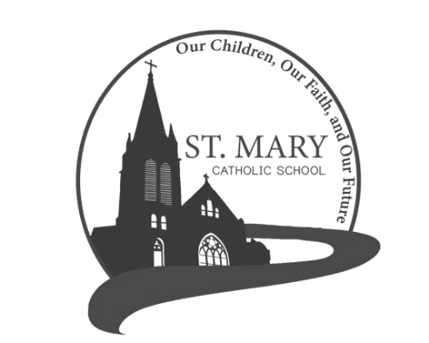
STUDENTS WILL BE DISSMISSED AT 11 A.M.!!!!!

Thank you to all the parents, grandparents, volunteers, parishioners, and our whole community who have shown us so much support through the years! May God Bless you all!

