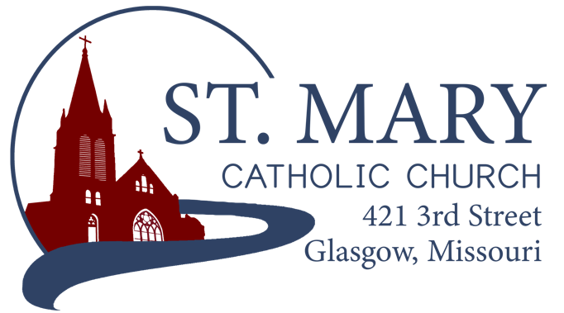

Mission Statement
We, the members of St Mary Parish, profess, practice, and proclaim our faith in Jesus Christ through word, sacraments, education and service.

EMAIL: parishoffice@stmarysglasgow.org
WEBSITE: www.glasgowstmary.com
FACEBOOK: St. Mary Church, Glasgow, MO

St. Mary Parish Office …………… 660-338-2053
St. Mary School Office …………...…… 660-338-2258

Parochial Administrator .….…… Fr. Joshua Duncan
School Principal …..…….……… Mr. Kent J. Monnig
Parish Bookkeeper/Secretary…. Wanda Fuemmeler

St. Mary Confessions:
Saturdays 4:00 – 5:15 pm

St. Mary Parish Office Hours:
Mon., Tues., Thurs.: 8 a.m. to 3 p.m.

St. Joseph Parish, Fayette – Schedule
Tuesday ……………. Mass 6:00 PM
Confessions 5:15 to 5:45 PM
Sundays……..……… Mass 8:30 AM
Confessions 7:45 to 8:15 AM
ST. MARY HOLY MASS SCHEDULE
Sun Nov. 21  10:00 am | People of St. Mary & St Joseph Parish
Tues Nov 23  (6:00 pm) | S.J. FAYETTE MASS
Wed Nov. 24  8:15 am | Jim & Joan Keogh†
Thurs Nov 25  8:15 am | Eugene & Henrietta  Hellebusch†
Fri Nov 26  8:15 am | Juliann Barringhaus†
Sat Nov 27  5:30 pm | Deceased members of  Vincent & Clara  Sellmeyer family†
Sun Nov. 28  10:00 am | William & Pauline Schafer†
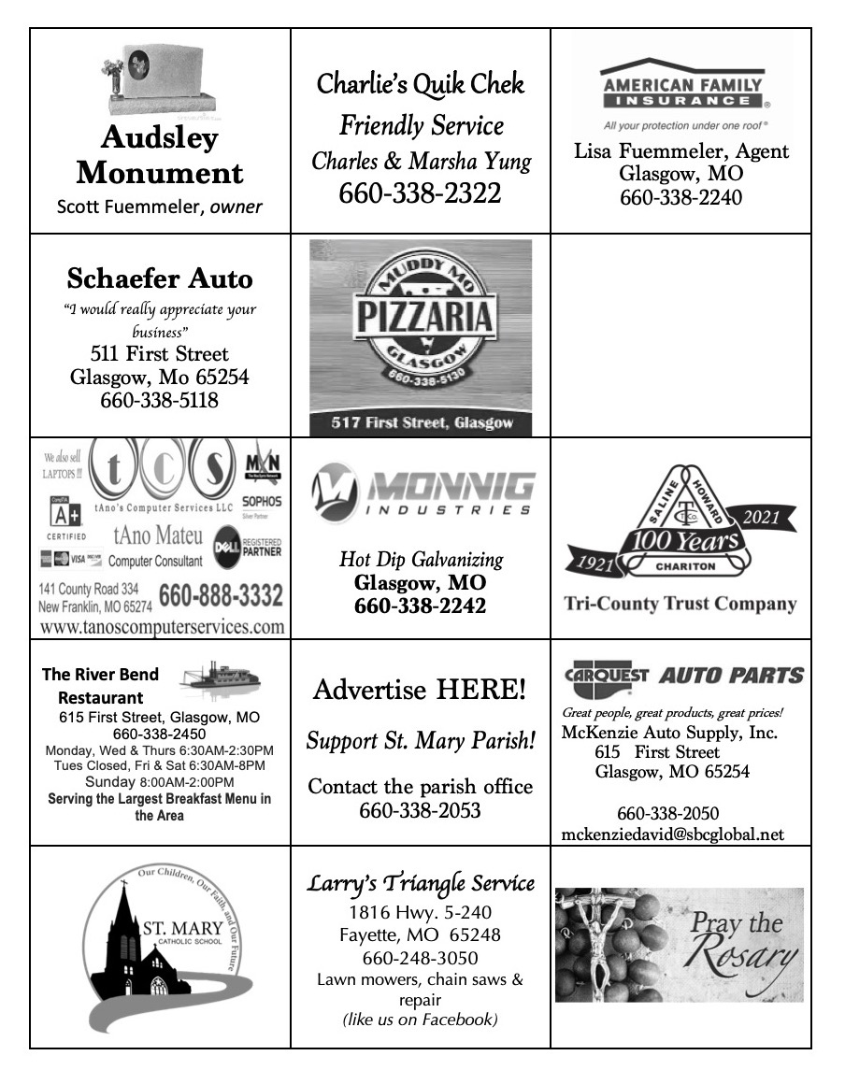
St. Mary Parish Tithing Stewardship
Nov 7, 2021 $ 9,698.00
Nov 14, 2021 $5,810.00
Nov 21, 2021 $
Nov 28, 2021 $
Total direct deposits $
Total for month $15,508.00

Offertory budget goal / month $48,076.92
Weekly goal $12,019.23
(Under) for two weeks ($8,530.46)

Offertory Goal Year-to-date $252,403.83
Offertory year-to-date $183,546.01
(Under) Budget year-to-date ($68,857.82)
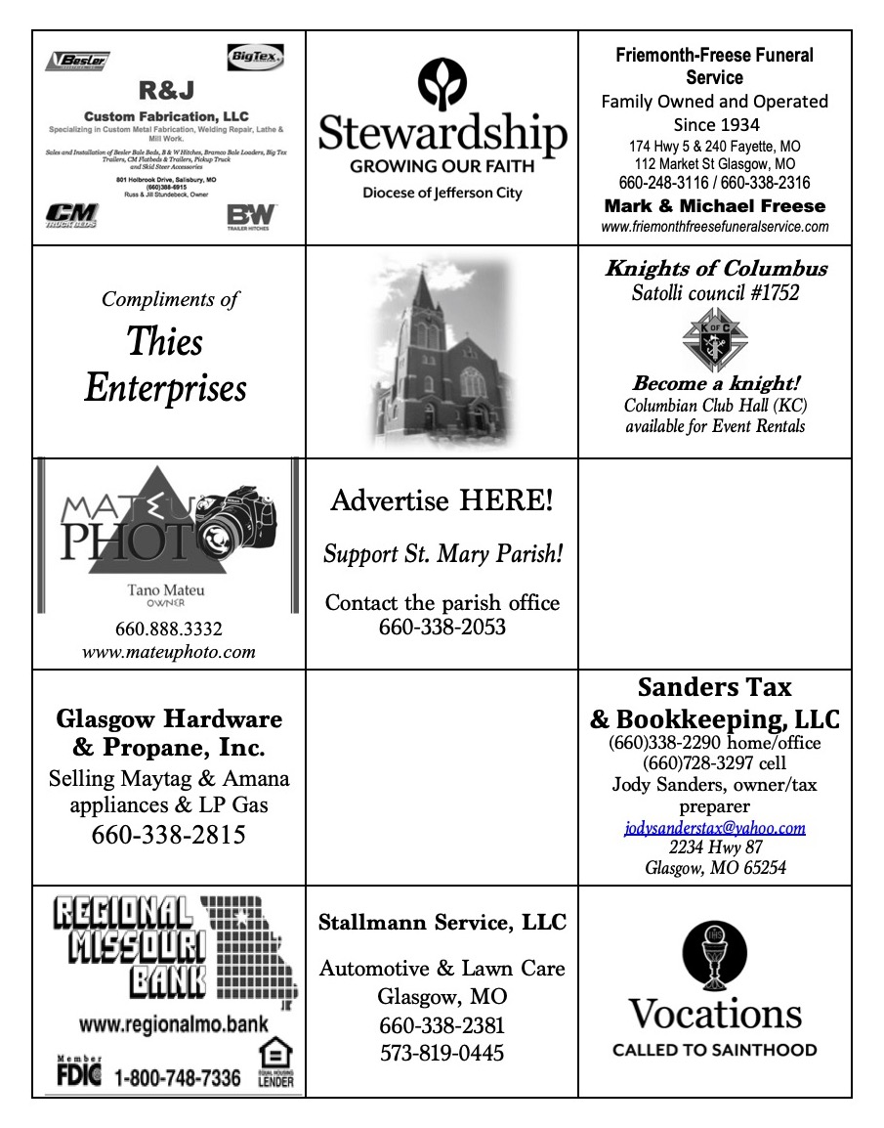
STEWARDSHIP – PARISH MINISTRIES
Sat. Nov 27  Rosary  Host Team  Lector  EO Ministers  Choir  Servers  Sun. Nov. 28  Rosary  Host Team  Lector  EO Ministers  Choir  Servers | 5:30 PM  Theresa Fuemmeler  Charlie & Jacob Monnig  Nick & Maclin Monnig  Megan Watts  Cindy Crowley  Mike Crowley (loft)  Seasonal Singers  Hudson Kallmeyer  Lane Monnig  10:00 AM  Melissa Boss  Michael Barringhaus Family  Amber Monnig  Cheryl Adams  David Brucks (loft)  SMS Choir  Alliyah Monnig  Christopher Schaefer
PLEASE PRAY FOR THE SICK
Ella Marie Wilson | Jason Monnig
Cindy Wilson Hall | Florence Weber
Dena Fitzgerald | Byron Stallo
Nursing Home Residents | All Military personnel and their families
Layla Johnson | Sam Audsley
Nina Bell Schafer | All Shut Ins
Suzanne Freese | Tony Monnig
Sister Jania Keogh | Greg Larm
Betty King | John Murphy
Tony Holt | Mary McCoy
Crystal Aholt | Mary Kay Noll
Father Paul Hartley | Gwen Brand
Sophia Friedrich | Lucille Vose
Dorothy Colvin | Margie Lewis
Wilma Christensen | Daniel Stallman
Blake Manken | Doris Gibbs
Cindy Crowley | Rhonda Hammons
Stacy Senor | Kevin Perry
Trish Lewis | Chance Lackland
Jim Aholt | Sheila Sellmeyer
Joe Fuemmeler | Will Beaman
Daniel Enyeart Michele Aholt
Gary Stallman Karen Alden
ST. MARY CAPITAL CAMPAIGN
Totals as of November 9, 2021
Pledged - $502,716.36
Goal - $500,000.00
Pledges received - $428,476.36
Yet to Receive - $74,240.00
Thank you!! Your generous support helps us to move forward to keep improving our campus.

       

2021-2022 CATHOLIC
STEWARDSHIP APPEAL (CSA)
Totals as of November 15, 2021
- Parish Goal = $13,260
- $ Received = $5,330 (40 % of goal)
- $ Committed = $5,700 (43% of goal)
Thank you to all who have given so far – if we reach our Parish goal, we will receive 10% of our goal back + 90% back of whatever we go over our goal as a rebate check from the diocese! Last year, because of your generosity, we met our goal and received $1,376 in return that helped with our general operating expenses. Thank you!

       

Bishop McKnight’s November prayer intention for our Local Church is: “For a deeper spirituality of stewardship among all the baptized: That from our gratitude for God’s many blessings we may offer our personal gifts & talents in service to the evangelizing mission of the Church.”

       

ST. MARY PARISH FALL DINNER –
THANK YOU!!
Thank you to everyone who helped make our Parish Fall Dinner a success. Our Church volunteers work with passion, dedication, and utmost sincerity to fulfil the mission of the Church. We are grateful for the time, treasures and talents devoted to the success of our Fall Dinner.
- The Head Committee
- The Kitchen Committee
- Fr. Duncan
THANKSGIVING MASS
Did you know that Eucharist (“Eucharistia”) literally means, “Thanksgiving”? Come celebrate Holy Mass with us on Thanksgiving Day – our normal 8:15 AM start time here at St. Mary.

       

ADVENT PENANCE SERVICES
Advent is traditionally a time to hold more times for the Sacrament of Confession. The following is a list of times & places where additional times and priests will hear confessions around the area:
- Thurs., Dec. 2 @ 7 PM – St. Peter, Marshall (5 priests)
- Thurs., Dec. 9 @ 6:30 PM – St. Mary, Glasgow (3 priests)
- Tues., Dec. 14 @ 7 PM – St. Joseph, Fayette (3 priests)
- Thurs., Dec. 16 @ 7 PM – Sts. Peter and Paul, Boonville (5 priests)

       

ADVENT SPIRITUAL REFLECTIONS
Our Parish has partnered with St. Joseph, Fayette, to provide free subscriptions to FORMED.ORG! Take advantage of this wonderful gift this Advent season by signing up if you haven’t done so already. It’s fast, easy, and FREE!
- Go to: signup.formed.org
- Enter 65254 or search St. Mary, Glasgow.
- Add your name and email address

FORMED also has daily Advent reflections that can be delivered right to your email inbox! This can be accessed by going to: daily.formed.org

FORMED also has a mobile App (Apple App Store, Google Play), AppleTV, and Roku -- search “Formed Catholic”, or you can access it from any web browser. Best of all, it is very easy to use – providing high quality Catholic material right to your device and your homes. Sign up today!
DEC. 8 – IMMACULATE CONCEPTION
*HOLY DAY OF OBLIGATION*
Wednesday, December 8, 2021, is a Holy Day of Obligation this year to celebrate the great Solemnity of the Immaculate Conception of the Blessed Virgin Mary! The Mass Schedule is:
- Dec. 7, 6:00 PM – St. Joseph, Fayette
- Dec. 8, 6:30 AM – St. Mary, Glasgow
- Dec. 8, 8:15 AM – St. Mary, Glasgow
Because of how it falls on the calendar this year, we are keeping St. Joseph and St. Mary’s normal Mass times the same and offering an additional 6:30 AM Mass that morning for those who want to attend Mass before heading to work.

       

CHRISTMAS MASS & WEEKEND SCHEDULES
Since Christmas falls on a Saturday this year, it will impact our weekend Mass schedule as well. Attending Mass on Friday or Saturday for Christmas does NOT satisfy our weekend Obligation to attend Mass. Therefore, it is necessary to attend Mass twice that that short time span (1 Mass for Christmas, 1 Mass for Sunday). Please note, in the absence of evening Vigil Mass on the 25th, there will not be the normal confessions that weekend – please plan to attend one of the many Advent Penance Services being offered, Confessions the week before, or schedule an appointment. Between our Parishes, we are going to offer the following Mass schedule for December 24 – 26, 2021:
- Christmas Eve, December 24
  - 7:00 PM, St. Mary, Glasgow
  - 9:00 PM, St. Joseph, Fayette
- Christmas Day, December 25
  - 8:00 AM, St. Joseph, Fayette
  - 10:00 AM, St. Mary, Glasgow
- Sunday, December 26 (Holy Family)
  - 8:30 AM, St. Joseph, Fayette
10:00 AM, St. Mary, Glasgow

WORD AMONG US BOOKLETS
The November & Advent Issues of the Word Among Us Daily Readings & Meditation booklets are available to you in the back of Church! Please take a copy to assist you in your daily prayer life! They are free of charge for these few months, but donations will help us continue to provide these booklets in the future. With a Parish subscription, they are roughly $1.32 / booklet. We currently have enough donated to continue providing these through March 2022! Thank you!

       

CHRISTMAS DECORATIONS
We are updating Christmas decorations for the interior and exterior of the church. If anyone would like to donate for this purpose, please drop your donation into a marked envelope and place it in the offering basket. Thank you!
- Current donations total = $1,905
- Spent (Outdoor nativity) = $540

       
NEW MISSALETTES
NEXT Weekend begins Advent and our new Liturgical Year (Year C). With that will come a switch in our usual Missalettes. You may notice that they will be a little larger – replaced only once a year. Why the switch?
- Current GIA prices were estimated at $1,900 for this upcoming year, with over $500 in shipping alone.
- Breaking Bread / OCP has significantly more quality music choices and is produced by a Catholic Company. Shipping is roughly $300 cheaper by only receiving them once a year.
- Yearly, we are anticipated to save about $350!
- Overall, this is more “bang for the buck” – paying less in shipping and receiving over 3x the music choices.

ST. MARY SCHOOL NEWS

STUDENT MASS
Our Mass before Thanksgiving Break will be on Tuesday, November 23rd, with the 8th graders as ministers. We will do a student collection at this Mass. We welcome parents, grandparents, and parishioners to join us at Mass and model their faith for the students.
SAVE THE DATE—Christmas Program for St. Mary School is Sunday, December 5th, at 4 PM, in the church.
Standardized Test Results/Progress Reports
Please check backpacks for Standardized Test and Progress Reports this week. For Standardized tests look for your child’s strengths and areas for growth. I like to look at the GE (grade equivalent). For that if your child is in 8th grade you would want to see 8.2 (eighth grade, 2nd month) or greater. I have also attached the sheet where I plot the student’s scores each year. With these scores we like to see a positive change of 10 to 15 points. This shows they had a good year of growth in that testing area. Please give the school and teachers a chance to study the information and we will be doing more with the results at our January inservice day.

Change of Calendar/Diocesan Changes that affect our calendar
Two things changed on the diocesan calendar this past week that I want to share them with you now so that you can plan accordingly for the spring. March 18th, Regional PD Day in Moberly has been canceled and that will be replaced with a Diocesan PD Day at Helias on March 21st. (NO SCHOOL FOR KIDS). Bishop McKnight has also granted all schools two extra days for Easter break this year. This is an incentive for our teachers and parents that have navigating all things COVID this year. Maybe knowing this far out, a special family time can be planned. This requirement came with the days: they have to happen during that week, can’t be used to makeup weather days, can’t come off the end of the year, etc. The second goal was to free up principals to go to the NCEA and feel comfortable being away from their buildings knowing that there is only 2 days of school that week that will be missed. We will be out of school from April 14th-20th for Easter break. Please call the office if you have any questions regarding these calendar changes.

