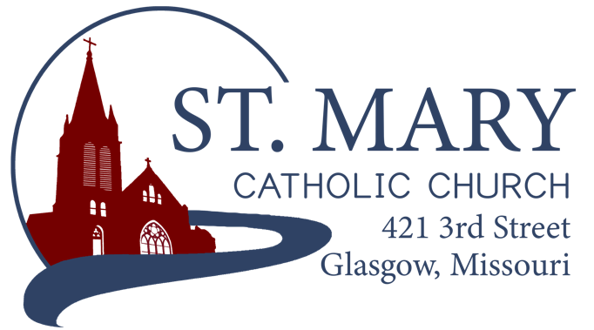

Mission Statement
We, the members of St Mary Parish, profess, practice, and proclaim our faith in Jesus Christ through word, sacraments, education and service.

EMAIL: parishoffice@stmarysglasgow.org
WEBSITE: www.glasgowstmary.com
FACEBOOK: St. Mary Church, Glasgow, MO

St. Mary Parish Office …………… 660-338-2053
St. Mary School Office …………...…… 660-338-2258

Parochial Administrator .….…… Fr. Joshua Duncan
School Principal …..…….……… Mr. Kent J. Monnig
Parish Bookkeeper/Secretary…. Wanda Fuemmeler

St. Mary Confessions:
Saturdays 4:00 – 5:15 pm

St. Mary Parish Office Summer Hours:
Tues., Wed., Thurs.: 8 a.m. to 3 p.m.

St. Joseph Parish, Fayette – Schedule
Tuesday ……………. Mass 6:00 PM
Confessions 5:15 to 5:45 PM
Sundays……..……… Mass 8:00 AM
Confessions 7:30 AM
ST. MARY HOLY MASS SCHEDULE
Sat June 18  5:30 pm | Father Paul Hartley†
Sun June 19  10:00 am | People of St Mary & St Joseph Parish
Tues June 21  (6:00 pm) | S.J. FAYETTE MASS
Wed. June 22  8:15 am | Gordon Glidden†
Thurs June 23  8:15 am | NO MASS
Fri June 24  8:15 am | Irvin & Mildred Fuemmeler†
Sat June 25  5:30 pm | Norman Herrington†
Sun June 26  10:00 am | Deceased members of Joe & Rita Thies family†
St. Mary Parish Tithing Stewardship
June 5, 2022 $7,875.00
June 12, 2022 $7,497.00
June 19, 2022
June 26, 2022
Total direct deposits $
Total for month $15,372.00

Offertory budget goal / month $48,076.92
Weekly goal $12,019.23
(Under) for two weeks ($8,666.46)

Offertory Goal Year-to-date $612,980.73
Offertory year-to-date $514,388.83
(Under) Budget year-to-date ($98,591.90)
STEWARDSHIP – PARISH MINISTRIES
Sat. June 25  Rosary  Host Team  Lector  EO Ministers  Choir  Servers  Sun. June 26  Rosary  Host Team  Lector  EO Ministers  Choir  Servers | 5:30 pm  Theresa Fuemmeler  Andy, Lindsey & Hudson Kallmeyer & Justin Friedrich  Erin Witte  Dan Thies  Brett Witte(loft)  Seasonal Singers  Robert Auck  Parker Monnig  10:00 AM  Melissa, Boss  Nick & Megan Meyer family  Anna McBride  Bill Daily  Jenny Westhues (loft)  SMS Choir  Britton Barringhaus  Samuel Stallman
PLEASE PRAY FOR THE SICK
Ella Marie Wilson | Jason Monnig
Cindy Wilson Hall | Byron Stallo
Nursing Home  Residents | All Military personnel  And their families
Dena Fitzgerald | Sam Audsley
Layla Johnson | All Shut Ins
Nina Bell Schafer | Tony Monnig
Suzanne Freese | Greg Larm
Sister Jania Keogh | John Murphy
Betty King | Mary McCoy
Tony Holt | Mary Kay Noll
Sophia Friedrich | Gwen Brand
Gary Stallman | Lucille Vose
Dorothy Colvin | Margie Lewis
Wilma Christensen | Daniel Stallman
Blake Manken | Doris Gibbs
Cindy Crowley | Rhonda Hammons
Trish Lewis | Kevin Perry
Daniel Enyeart | Chance Lackland
Karen Alden | Sheila Sellmeyer
Damian Barton | Will Beaman
Wayne Aholt  Charlie Yung | Tim Brooks

NEW PARISH OFFICE HOURS FOR THE SUMMER:
TUESDAY, WEDNESDAY, & THURSDAY FROM 8 AM TO 3 PM.
       
ST. MARY CAPITAL CAMPAIGN
Totals as of June 8, 2022
Pledged - $490,364.36 (98%)
Goal - $500,000.00
Pledges received - $452,766.36 (90%)
Yet to Receive - $37,598.00
Thank you!! Your generous support helps us to move forward to keep improving our campus.
       
Bishop McKnight’s June prayer intention for our Local Church is: “For all fathers; that through the intercession of St. Joseph they will be able to use their skills and gifts to love and provide for their children and raise them in the faith.” 
       
2021-2022 CATHOLIC
STEWARDSHIP APPEAL (CSA)
Totals as of June 15, 2022
- Parish Goal = $13,260
- $ Received = $13,350 (100.7% of goal)
- $ Committed = $14,225 (107% of goal)
Thank you to all who have given. This is our last diocesan-wide collection of this nature.
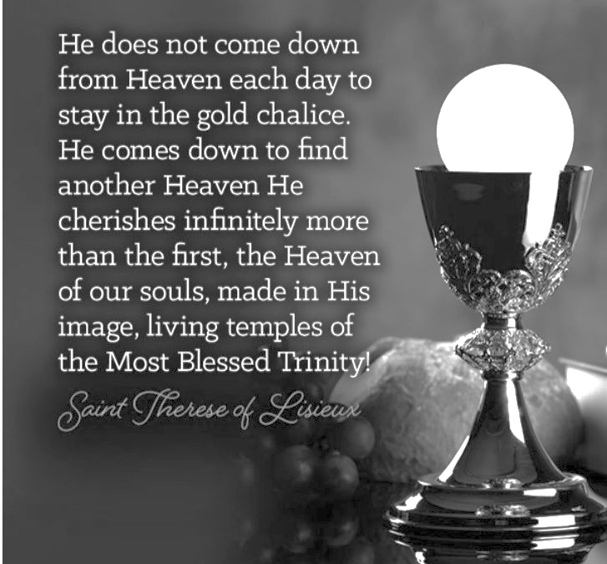

NO MASS THURSDAY
There will not be any Mass this Thursday, June 23 – Fr. Duncan will be out of town.
       
JUNE STEWARDSHIP PRAYER
Generous and loving God, you call us to be disciples of your Son Jesus And good stewards of all your many gifts. Open our mind and hearts
to a greater awareness and deeper appreciation
of your countless blessings. Transform us through the power of your Spirit to nurture a Stewardship way of life marked by faith-filled prayer, service to our neighbor, and generous sharing. Teach us to be faithful servants of your gifts. With Mary’s help, may we return tenfold the gifts entrusted to us.
We pray through Christ, our Lord. Amen.
       
(OTHER) SUMMER 2022
YOUTH OPPORTUNITIES
More information on each of these opportunities & sign up forms (online form) can be found at:
www.diojeffcity.org/youth-ministry
* CAMP LOLEK: (new) for Jr. High students (incoming 6th to 8th graders) $150 cost. We are excited to have many of our Jr. High Students already registered for this camp!
- Boys: July 10-13 / Girls: July 13-16
* CAMP MACCABEE: 5-day adventure camp for (High School) incoming Freshman to incoming Senior guys. $150 cost. Two opportunities:
- July 17-22
* CAMP SIENA: 5-day adventure camp for (High School) incoming Freshman to incoming Senior women. $150 cost.
- June 26 – July 1
       
THANK YOU – KofC!
A huge thank you to the Knights of Columbus who have renewed our Parish’s Formed.org subscription for this coming year. If you haven’t yet signed up – it’s free! formed.org/signup
TOTUS TUUS – (“Totally Yours”)
ST. MARY = JUNE 25 – JULY 1, 2022
PLEASE WELCOME OUR TOTUS TUUS YOUNG ADULT LEADERS!
TEAM “STS. PETER AND PAUL” –
- Ayanda Huate: I’m from Maputo, Mozambique. I’ve been living in Missouri for two years and studying at Westminster College in Fulton. I am passionate about languages, cultures, and people! I am very excited to teach our beautiful faith!
- Garren Gray: I am from Rolla, MO and am a senior at MS&T studying Philosophy. My dream is to teach and become a professor of Philosophy and Religion. I love playing board games and video games with my friends at Newman.
- Gage Neisen: I am a seminarian for the Diocese of Jefferson City from Lewistown, MO. I am a junior in college seminary at Holy Trinity Seminary in Dallas, Texas. I am the second oldest of four children in my family. My two favorite past times are listening to classic rock and playing ping pong. I also love the Rosary and oatmeal raisin cookies.
- Abby Thompson: I am from Columbia where I live with my family. I love camping, hiking, and playing music with my three siblings.
Thanks to everyone who has already registered and donated to help with Totus Tuus week! Registration and volunteer forms are in the back of church. Please return them or contact Erin Witte with any questions or if you can contribute. 573-489-1480
TOTUS TUUS PARISH POTLUCK –
ALL PARISHIONERS INVITED!
There will be a parish potluck on Wednesday, June 29th at Kuemmel Park at 5:00 pm. Hot dogs, hamburgers, water and table service will be provided.
       
CASSEROLE COMMITTEE
The Casserole Committee is ready to provide for any parish member/family in need. If you or someone you know could use the help of the Committee, please reach out to:
* Megan Meyer 573-881-7021
* Jessica Chrislaw 660-672-9068
* Molly Monnig 660-888-1483
       
CURSILLO WEEKEND
Socrates said that an un-examined life is not worth living. Yet, in order to do this, one has to deliberately carve out a block of time to study oneself and the world with a goal of becoming a more balanced, better human being. Making a Cursillo Weekend is a once-in-a-lifetime opportunity to examine one’s life and figure out what is truly important. Cursillo is a Spanish word (pronounced koor-SEE-yo); it is a short course for all adult Catholics that emerged in Spain and quickly spread through most of the world. It involves spending an extended weekend in a quiet and reflective environment with other Catholics guided by a priest, a deacon and other laity. This team provides for your spiritual and physical needs while you explore the question, WHAT IS A CATHOLIC LIFE WELL-LIVED? Fortunately, the next Cursillo weekends will be held in Columbia, Missouri. Here are the dates:
* Men: starts the evening of July 14-July 17th
* Women: starts the evening of August 4 -August 7th
Contact Tammy McMillan 660-728-9936 with any questions and to request an application to make your Cursillo weekend.
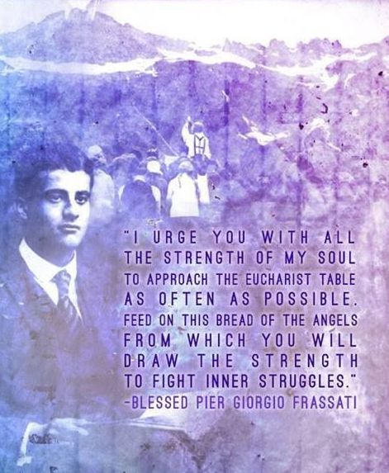
       
ST. MARY SCHOOL NEWS

HAVE A HOLY, BLESSED, AND RESTFUL SUMMER VACATION!
SEE YOU AT MASS!

THANK YOU / LITTLE SAINTS
A huge thank you to all who donated to our Preschool Little Saints via the Little Saints Giving Tree that was in the back of Church this Spring. All the little saints were ordered except for 3—we are waiting on restock. These little saints will be played with and loved by our preschool friends. They will also be brought to church during the week by our little preschool friends. Thank you for helping us “raise saints” through your generous donations!
PRESCHOOL 2022-2023 UPDATES!
Renovation construction on the shed is making great progress – we are currently on schedule to be completed before the end of July, and on budget!

WE ONLY HAVE 3 SLOTS LEFT FOR PRESCHOOL! We currently have 17 little ones enrolled for this upcoming school year – drawing from the following communities: Glasgow, Fayette, Salisbury, and New Franklin. We are excited for the future of St. Mary Catholic School serving all of Howard County – and beyond!

AFTERSCHOOL CARE – 2022-2023
Registration forms will be soon available. Registration is monthly for a discounted rate, or there will be a regular “drop-in” daily rate, provided the space and staff are available. If you register using the monthly discounted rate – you’re welcome to use afterschool care as often or as little as you’d like for that month – your child(ren) will have a spot guaranteed for the month you registered. Look for the forms with more information coming soon! If you or someone you know would like to work – it is a paid position, and the hours would be roughly 2:45pm – 5:45pm (M-F). Please contact the School Office.

