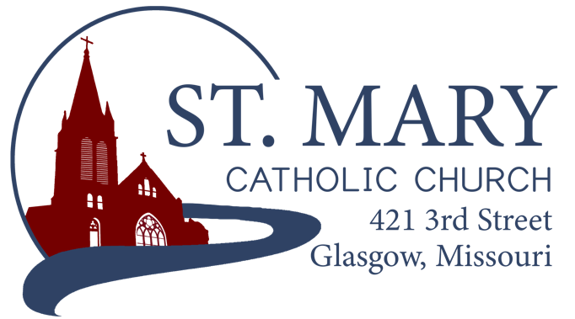
Mission Statement
We, the members of St Mary Parish, profess, practice, and proclaim our faith in Jesus Christ through word, sacraments, education and service.

EMAIL: parishoffice@stmarysglasgow.org
WEBSITE: www.glasgowstmary.com
FACEBOOK: St. Mary Church, Glasgow, MO

St. Mary Parish Office …………… 660-338-2053
St. Mary School Office …………...…… 660-338-2258

Parochial Administrator .….…… Fr. Joshua Duncan
School Principal …..…….……… Mr. Kent J. Monnig
Parish Bookkeeper/Secretary…. Wanda Fuemmeler

St. Mary Confessions:
Saturdays 4:00 – 5:15 pm

St. Mary Parish Office Hours:
Mon., Tues., Thurs.: 8 a.m. to 3 p.m.

St. Joseph Parish, Fayette – Schedule
Tuesday ……………. Mass 6:00 PM
Confessions 5:15 to 5:45 PM
Sundays……..……… Mass 8:30 AM
Confessions 7:45 to 8:15 AM
ST. MARY HOLY MASS SCHEDULE
Sun Sept 26  10:00 am | James Brucks †
Tues Sept.28  (6:00 pm) | S.J. FAYETTE MASS
Wed Sept. 29  8:15 am | Adolph & Ida Barringhaus†
Thurs Sept 30  8:15 am | Mason Imhoff †
Fri Oct. 1  8:15 am | Sister Mary Westhues†
Sat Oct 2  5:30 pm | Deceased members of Jim & Jane Holtwick family †
Sun Oct 3  10:00 am | People of St Mary & St Joseph Parish
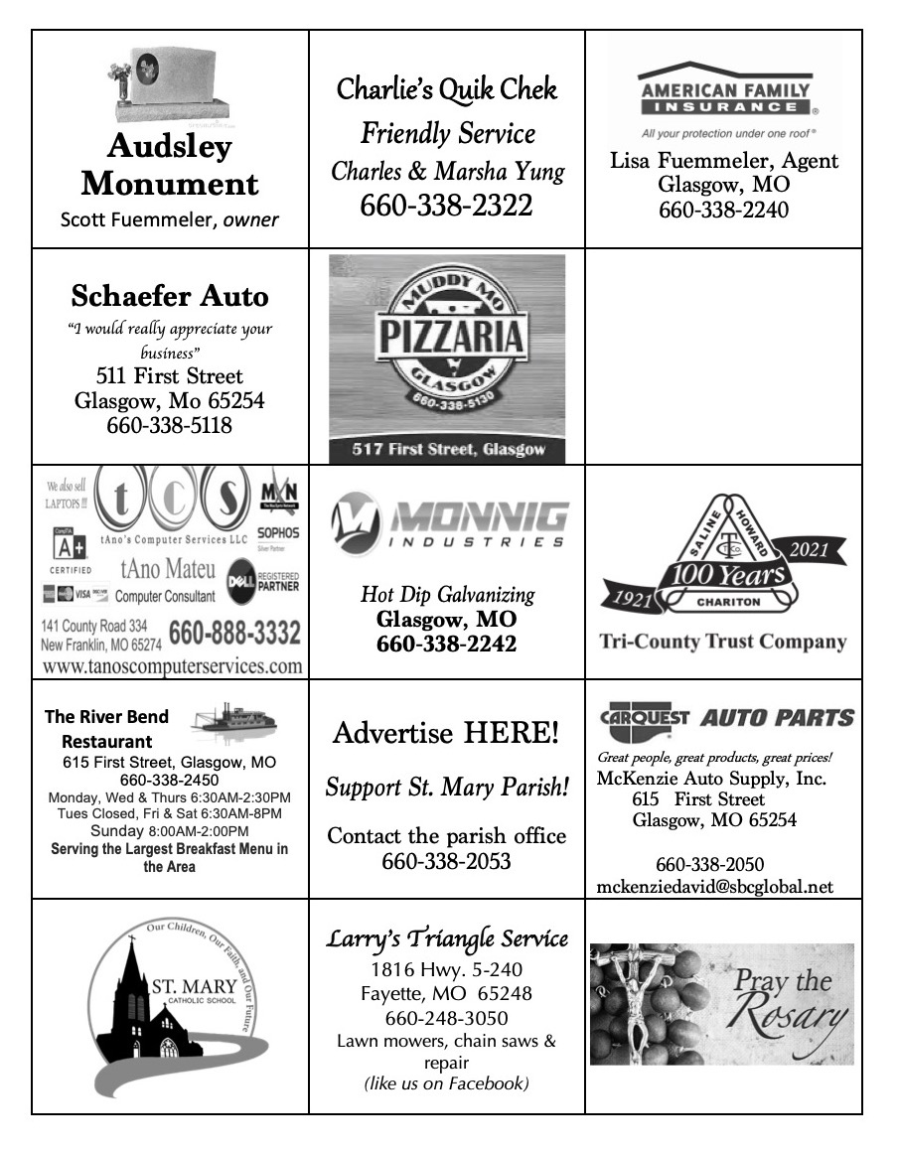

St. Mary Parish Tithing Stewardship
Sep 5, 2021 $7,236.00
Sep 12, 2021 $5,192.00
Sep 19, 2021 $8,202.00
Sep 26, 2021 $
Total direct deposits $
Total for month $20,630.00

Offertory budget goal / month $48,076.92
Weekly goal $12,019.23
(Under) for three weeks ($15,427.69)

Offertory Goal Year-to-date $156,249.99
Offertory year-to-date $105,696.26
(Under) Budget year-to-date ($50,553.73)

STEWARDSHIP – PARISH MINISTRIES
Sat. Oct 2  Rosary  Host Team  Lector  EO Ministers  Choir  Servers  Sun. Oct 3  Rosary  Host Team  Lector  EO Ministers  Choir  Servers | 5:30 PM  Adolph & Diane Barringhaus  Robert Wood & Jenna Lee family  Sonya Fuemmeler  Herb Fuemmeler  Anna McBride (loft)  Cecilia’s Voice  Bridger Ewings  Lillian Thies  10:00 AM  Bill Daily  Josh & Terin Fuemmeler family, Cheryl Adams  Amber Monnig  Bill Daily  Gary Fuemmeler (loft)  Rise Up & Rejoice  Tyler & Ryleigh Barringhaus
PLEASE PRAY FOR THE SICK
Ella Marie Wilson | Jason Monnig
Cindy Wilson Hall | Marvin Crowley
Dena Fitzgerald | Byron Stallo
Nursing Home Residents | All Military personnel and their families
Layla Johnson | Sam Audsley
Nina Bell Schafer | All Shut Ins
Suzanne Freese | Tony Monnig
Catherine Schaefer | Greg Larm
David F. Monnig | John Murphy
Sister Jania Keogh | Mary McCoy
Tony Holt | Mary Kay Noll
Crystal Aholt | Gwen Brand
Father Paul Hartley | Emmett Schroeder Sapp
Sophia Friedrich | Lucille Vose
Dorothy Colvin | Margie Lewis
Karen Gebhardt | Daniel Stallman
Blake Manken | Inez Wachter
Cindy Crowley | Doris Gibbs
Stacy Senor | Rhonda Hammons
Betty King | Kevin Perry
Trish Lewis | Chance Lackland
Joe Fuemmeler Sheila Sellmeyer
Daniel Enyeart Will Beaman
St. Mary Parish Capital Campaign
Totals as of September 8, 2021
Pledged - $370,682.00
Goal - $500,000.00
Pledges received - $287,720.00
Thank you!! Your generous support helps us to move forward to keep improving our campus.

       

Bishop McKnight’s September prayer intention for our Local Church is: “For a greater appreciation for the gift of friendship; that bonds of friendship may strengthen our resolve to be a people of communion in divisive times.”

** PARISH FALL DINNER 2021 **
Gobble, Gobble, fall dinner season is almost here!
- Be sure to stop by the table at the Church entrance to sign up for your food donations for the fall dinner. This is the new way of soliciting for bread/rolls, potatoes, butter, milk, pies and money for meat. Thank you for contributing!
- The fall dinner is scheduled for Sunday, November 14th from 11:00-2:30. We will again be doing a drive-thru system like last year with limited in-town and neighboring parish deliveries. Limited outdoor seating will also be available behind school and in front of the KofC hall, weather-permitting.
- Craft corner, raffle, etc will be at the K of C hall.
- Parish letters will be coming out soon with more details.

MINISTRY VOLUNTEER REMINDER
If you are unable to fulfill your Parish Ministry / Liturgical Volunteer Role, please ask someone else to fill in for you / find a substitute. It helps to prevent us scrambling at the last minute to find someone. Thank you!

WORD AMONG US BOOKLETS
The October Issue of the Word Among Us Daily Readings & Meditation booklets are available to you in the back of Church! Please take a copy to assist you in your daily prayer life! They are free of charge for these few months, but donations will help us continue to provide these booklets in the future.

       

FALL 2021 CONFIRMATION
Our 7th Graders are working on Confirmation Preparations for our November 10th Confirmation (6:30pm). Please see the forms that will be sent home.
- St. Mary Grade school students use their regular religion class time for their “academic portion” of the program.
- PSR Students meet at St. Joseph, Fayette after the 8:30am Mass for the “academic portion”. (Sept. 12, 19 +)
PLEASE RSVP! – for a group Service + Social Confirmation activity – Sunday, September 26 from 12-noon to about 4:30pm. Meet at St. Joseph Parish Hall for lunch. See the flyer to be sent home with your students.

       

MARIAN CONFERENCE

ST. JOSEPH CATHOLIC CHURCH WESTPHALIA, MO
Friday, November 12, 2021 – 5-9 PM
Saturday, Nov. 13, 2021 – 6:30am – 4:30pm
Info + Registration =
www.stjosephwestphalia.org
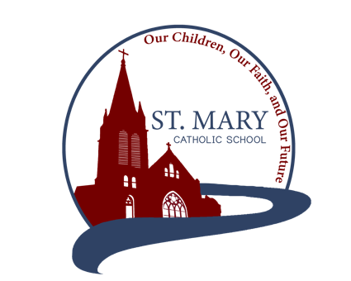
Adoration, Confession, Relics, Guest Speakers, Music, Resources. This is a free event!

ST. MARY SCHOOL NEWS

Student Mass
All school Mass Wednesday, September 29th, with 4th graders as ministers. Friday, October 1st, will be a special memorial Mass for Sister Mary Westhues. Students related to the family will do the parts, with the whole student body in attendance. We also do a student collection every Friday. Remember that students may wear school uniform shorts on Wednesdays but not on Fridays.

K & 1st Grade Mission Project
The kindergarten and 1st grade are going to kick off our class Mission projects with an Apple Bar on Friday, October 1st. They are hosting an Apple Bar behind school.S Students will have a chance to buy an apple and then add toppings like M&M’s, chocolate chips, oreos, mini snickers, peanut butter, sprinkles, chocolate and carmel syrup, etc. Apple juice boxes will also be available. The apple and toppings will cost $1 and the juice boxes will be $.50. Mark you calendar and get money ready for your kids to enjoy this special treat.

School Picture Day/Mark the Calendar
Fall Picture Day is scheduled for Tuesday, October 12th. Student will be out of uniform for the day. Informational envelopes will be sent home sooner to the date.

School Bread Challenge
The Fall Dinner has contacted the school for help and so we are up to the challenge of getting 160 loaves of bread donated for the Fall Dinner. Our source for free bread no longer exists and since families do not have to donate items for the game room, we were thinking that we could ask our school and parish families to do this for us. So, if we can get 160 loaves of bread to our school by Friday, October 29th, the kids and teachers will get a dress down day on Thursday, November 11th. Parishioners that do not have kids or grandkids in our school are welcome to
help us reach our goal as well. We will put a tub in church that those that want to drop off there. Plain white sandwich bread seems to work the best, but any kind will do. We have access to an empty freezer for storage and will keep track of the amount as well. The bread can be sent with the kiddos any day starting this coming Monday. If each school family did 2 loaves, we would easily reach our goal. Thank you!

VOLUNTEER BUILDING AND GROUNDS COMMITTEE NEEDED - At School Board, we talked about the possibility of forming a volunteer committee of parents to do projects on the grounds and buildings of our campus. With the move to a new stewardship model, this seems to fit in with parents being able to share of the time and talents. Jenna Lee has volunteered to help organize this group and has asked that we start putting a wish list of projects together for the school. A similar list will be developed by Fr. Duncan to address the cleaning and maintenance of the church as well.

SCHOOL CALENDAR – FEEDBACK
I am seeking feedback on reinstating the Monday after Fall Dinner back into the calendar as a school day. It was presented at School Advisory as a help to parents, so we decided to put it back it. Since I have received some feedback that plans have been made and they would prefer that we not put the day back in the calendar. At this point it is back on the agenda for the October School Advisory Board. Please send me input via a note or email so we can make a decision based on a wider body of the school population. Thank you!

Math Monday
Now that we have got into the regular routine of school and since we have had to do some remote learning, some of our students may need a little extra help getting caught up in Math. I will start offering Math tutoring again on Mondays after school from 3:00 to 4:00 PM for any 6th-8th grader needing some extra help.

VIRTUS Training
If a parent in you family is still needing to complete Virtus Training, the paperwork with the initial instructions has been sent home with your child. Remember this is NOT OPTIONAL but a diocesan requirement as part of enrollment in our school. It is all available online. We have set October 21st as the cut off date. After that date, without special permission from Fr. Duncan or Mr. Monnig, your child will not be allowed to be in school. Please do not put us in that position. If you need assistance in doing this training or need computer access, Mrs. Reeves and the school will help you out when you come in for Parent/Teacher Conferences on October 21st. Thank for your prompt cooperation in this matter.

