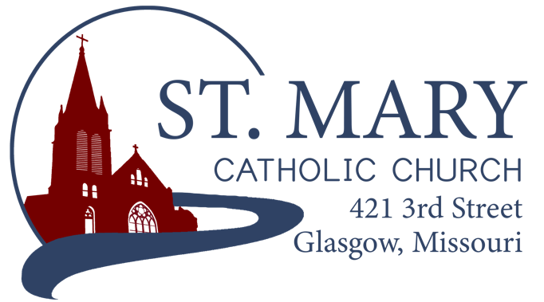

Mission Statement
We, the members of St Mary Parish, profess, practice, and proclaim our faith in Jesus Christ through word, sacraments, education and service.

EMAIL: parishoffice@stmarysglasgow.org
WEBSITE: www.glasgowstmary.com
FACEBOOK: St. Mary Church, Glasgow, MO

St. Mary Parish Office …………… 660-338-2053
St. Mary School Office …………...…… 660-338-2258

Parochial Administrator .….…… Fr. Joshua Duncan
School Principal …..…….……… Mr. Kent J. Monnig
Parish Bookkeeper/Secretary…. Wanda Fuemmeler

St. Mary Confessions:
Saturdays 4:00 – 5:15 pm

St. Mary Parish Office Hours:
Mon., Tues., Thurs.: 8 a.m. to 3 p.m.

St. Joseph Parish, Fayette – Schedule
Tuesday ……………. Mass 6:00 PM
Confessions 5:15 to 5:45 PM
Sundays……..……… Mass 8:30 AM
Confessions 7:45 to 8:15 AM
ST. MARY HOLY MASS SCHEDULE
Sun Nov. 7  10:00 am | People of St. Mary & St Joseph Parish
Tues Nov 9  (6:00 pm) | S.J. FAYETTE MASS
Wed Nov. 10  8:15 am | Jerome Brucks†
Thurs Nov 11  8:15 am | William & Pauline Schafer†
Fri Nov 12  8:15 am | Lorene Pfeifer†
Sat Nov 13  5:30 pm | James Brucks†
Sun Nov. 14  10:00 am | Gary Fuemmeler†
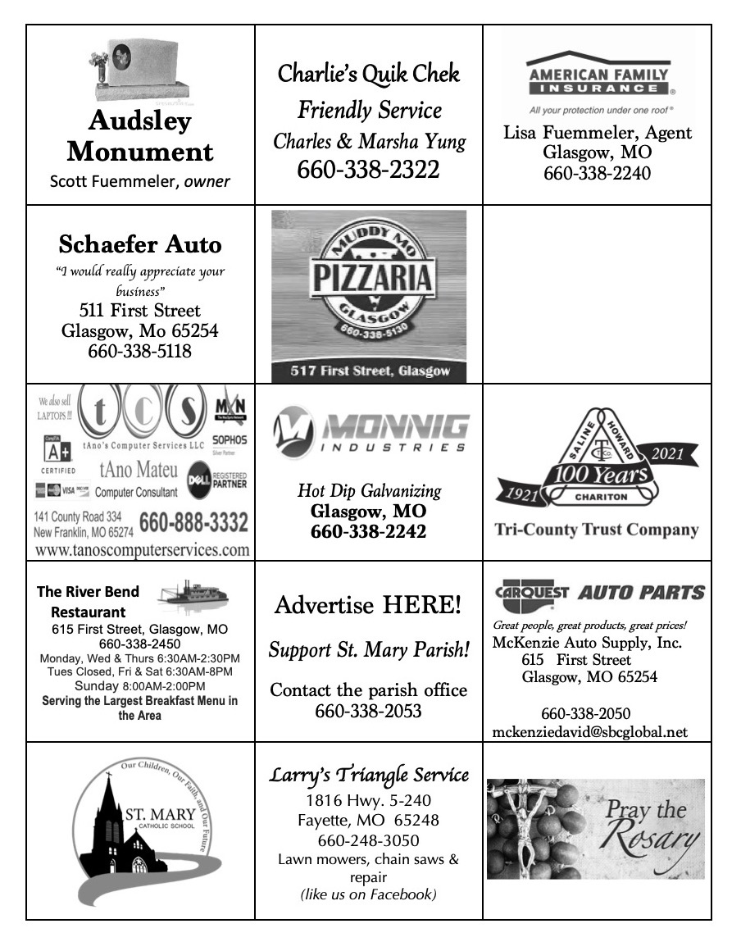
St. Mary Parish Tithing Stewardship
Oct 3, 2021 $12,129.00
Oct 10, 2021 $5,593.00
Oct 17, 2021 $5,332.00
Oct. 24, 2021 $3,943.00
Oct. 31, 2021 $6,048.00
Total direct deposits $3,928.81
Total for month $ 36,973.81

Offertory budget goal / month $48,076.92
Weekly goal $12,019.23
(Under) for month ($11,103.11)

Offertory Goal Year-to-date $228,365.37
Offertory year-to-date $160,529.28
(Under) Budget year-to-date ($67,836.09)
STEWARDSHIP – PARISH MINISTRIES
Sat. Nov 13  Rosary  Host Team  Lector  EO Ministers  Choir  Servers  Sun. Nov. 14  Rosary  Host Team  Lector  EO Ministers  Choir  Servers | 5:30 PM  Marjorie Thies  Mark & Jamie Thies Family  Sonya Fuemmeler  Dan Thies  Brett Witte (loft)  Seasonal Singers  Aslan & Reese Witte  10:00 AM  Bill Daily  Peggy Fuemmeler, Jenny Westhues & Phil Hackman  Anna McBride  Bill Daily  Kent Monnig (loft)  SMS Choir  Tenley Fuemmeler  Cash Westhues
PLEASE PRAY FOR THE SICK
Ella Marie Wilson | Jason Monnig
Cindy Wilson Hall | Florence Weber
Dena Fitzgerald | Byron Stallo
Nursing Home Residents | All Military personnel and their families
Layla Johnson | Sam Audsley
Nina Bell Schafer | All Shut Ins
Suzanne Freese | Tony Monnig
Sister Jania Keogh | Greg Larm
Betty King | John Murphy
Tony Holt | Mary McCoy
Crystal Aholt | Mary Kay Noll
Father Paul Hartley | Gwen Brand
Sophia Friedrich | Lucille Vose
Dorothy Colvin | Margie Lewis
Wilma Christensen | Daniel Stallman
Blake Manken | Doris Gibbs
Cindy Crowley | Rhonda Hammons
Stacy Senor | Kevin Perry
Trish Lewis | Chance Lackland
Jim Aholt | Sheila Sellmeyer
Joe Fuemmeler | Will Beaman
Daniel Enyeart Michele Aholt
Gary Stallman
St. Mary Parish Capital Campaign
Totals as of October 12, 2021
Pledged - $501,750.49
Goal - $500,000.00
Pledges received - $421,973.95
Yet to Receive - $79,776.54
Thank you!! Your generous support helps us to move forward to keep improving our campus.

       

Bishop McKnight’s November prayer intention for our Local Church is: “For a deeper spirituality of stewardship among all the baptized: That from our gratitude for God’s many blessings we may offer our personal gifts & talents in service to the evangelizing mission of the Church.”

       

ST. MARY PARISH FALL DINNER – NEXT WEEKEND!
-- If you haven’t received a worker card and want to work, please contact Jenna Lee or a committee member.
-- Thank you to all who have already signed up to donate items for the Fall Dinner! We are still really short on pies and homemade breads/rolls. Please consider helping out with this.
-- All volunteers are being asked to complete the Virtus Program for the diocese.
-- This year coleslaw will be optional on all orders. Bottled water and tea will be available at time of purchase--for drive-thru only.
-- Pre-orders for in-town deliveries need to be made by Nov. 7th. Please contact Kathleen Thies to place your orders: 338-2409.

       

ST. MARY OCTOBER COUNT NUMBERS
Oct. 2-3 = 125 / 207
Oct. 9-10 = 105 / 186
Oct. 16-17 = 124 / 163
Oct. 23-24 = 137 / 168
Oct. 30-31 = 101 / 208

Calling All Cursillistas
Please attend the Women's #77 Weekend Closing Ceremony (Closura) at St. Pius X in Moberly, this Sunday, November 7 at 4pm.
Consider carpooling with others to show our support of their new 4th Day!

       

FALL 2021 CONFIRMATION
Confirmation for our 7th Grade School and CCD kids is THIS WEDNESDAY EVENING – NOVEMBER 10, 6:30 PM. Information regarding the ceremony was previously sent home with the candidates. A few things to take note of:
- Retreat: TODAY / Sunday, November 7th, 12noon to 5 PM at St. Joseph, Fayette in the Parish Hall.
- Rehearsal: following the retreat in St. Joseph Church
- Dress/Other notes: See the sheet that was sent home.
Any questions, please contact Fr. Duncan – jduncan@diojeffcity.org

       

WORD AMONG US BOOKLETS
The November Issues of the Word Among Us Daily Readings & Meditation booklets are available to you in the back of Church! Please take a copy to assist you in your daily prayer life! They are free of charge for these few months, but donations will help us continue to provide these booklets in the future.

       

CHRISTMAS DECORATIONS
We are attempting to restore an outdoor nativity set and updating Christmas decorations for the interior of the church. If anyone would like to donate for this purpose, please drop your donation into a marked envelope and place it in the offering basket. Any assistance would be appreciated.

       

**SAFE ENVIRONMENT
(VIRTUS) COMPLIANCE**

All Parishioner volunteers in every Parish in the Diocese of Jefferson City, at the direction of the Bishop, are required to have the necessary Safe Environment training to be compliant with the Dallas Charter enacted by the USCCB in 2002.

WHO is this for?
- ALL Employees of the Parish/School.
- ALL Parents of children enrolled in our Parish’s Catholic School.
- ALL Parish Volunteers (Lectors, EMHC, Musicians, Fall Dinner, etc.) 18yr and older

WHAT does it require?
- An online Account, registered through www.virtusonline.org
- IF you are brand new to the VIRTUS website, please train through the ONLINE portal. If you need help with this, please contact the Parish Office for a detailed instruction sheet or contact the Diocesan Chancery (573.635.9127).
- IF you already have a VIRTUS account (some parishioners do from 2003 onward), but are inactive, lost your password, aren’t sure about login information, or aren’t sure about what you need to do to “get current” – please contact the Diocesan Chancery (573.635.9127) and ask the receptionist for “help with my VIRTUS account”.
- IF you are NOT an employee, you only need to go through the training once, complete the background check information (online), and read the Code of Conduct – and you are good for forever! (As long as the diocese is using VIRTUS).
  - There are no “ongoing bulletins” to mess with. It’s a one-and-done.
- IF you ARE an employee, you only need to keep current on the assigned trainings once every couple of years.

ST. MARY SCHOOL NEWS

STUDENT MASS
Mass next week will be on Thursday, November 11th, with the 4th graders having the ministries. We will do a student collection that day as well.

November 10th - Veterans Day Program/ CHADS presentation for 5-8 graders. Confirmation for our 7th Graders in the evening.
November 15th - Day of school for students/approved at Advisory Board
November 19th - Flu Vaccinations for those that signed up for them

SAVE THE DATE—Christmas Program for St. Mary School is Sunday, December 5th, at 4 PM, in the church.

Dress Down Day and/or Spirit Day is NOVEMBER 9th
The dress down day, earned by reaching our bread goal, has been moved to Tuesday, November 9th. This is also our last home basketball game, you could wear spirit wear to cheer them on. I will try to send out a REMIND that morning to help all remember. Thank you for helping exceed our bread goal! Hopefully everyone will be doing their part to make our Fall Dinner a success.

Memorials to the school
Thanks to the David Monnig (Cindy) family and the Gary Fuemmeler family for the recent memorials to the school.

Upcoming Basketball Games
The jaguars have had some busy weeks of basketball. The players, coaches, and parents are doing a good job of supporting this program. This year all concessions and ½ of the door profits are going into our newly developed athletic fund. One of the first goals with this fund will be to work towards replacing our aging basketball uniforms. We have Mendon away on Monday, November 8th and our last home game on Tuesday, November 9th verses St. Pius. They will finish up the season with the St. Joe tournament November 15-19th! GO JAGUARS!

Donations to Benefit the School
St. Mary School would like to thank all that collect milk caps, ink cartridges, and best choice for the school. We recently received a check for $120 from Best Choice. Thanks to Julie Monnig for processing these for the school. We also want to acknowledge the $500 from D of I of Boonville/Glasgow, where 8 of our ladies joined their group since the one at St. Mary Church disbanded earlier in the year. George Brucks, Jr. has made a generous donation again this year to benefit the school, students, and teachers. We also received $1000 donation from Affiliated Farm Management. Some of the money from these donations will cover the cost of implementing our new Accelerated Reading Program, that will be available in 2022.
