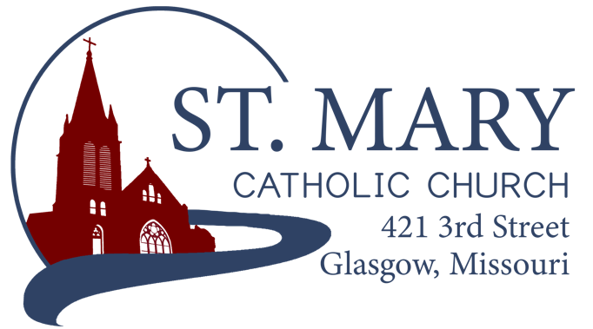
Mission Statement
We, the members of St Mary Parish, profess, practice, and proclaim our faith in Jesus Christ through word, sacraments, education and service.

EMAIL: parishoffice@stmarysglasgow.org
WEBSITE: www.glasgowstmary.com
FACEBOOK: St. Mary Church, Glasgow, MO

St. Mary Parish Office …………… 660-338-2053
St. Mary School Office …………...…… 660-338-2258

Parochial Administrator .….…… Fr. Joshua Duncan
School Principal …..…….……… Mr. Kent J. Monnig
Parish Bookkeeper/Secretary…. Wanda Fuemmeler

St. Mary Confessions:
Saturdays 4:00 – 5:15 pm

St. Mary Parish Office Hours:
Mon., Tues., Thurs.: 8 a.m. to 3 p.m.

St. Joseph Parish, Fayette – Schedule
Tuesday ……………. Mass 6:00 PM
Confessions 5:15 to 5:45 PM
Sundays……..……… Mass 8:30 AM
Confessions 7:45 to 8:15 AM
ST. MARY HOLY MASS SCHEDULE
Sun Oct 24  10:00 am | William & Pauline Schafer†
Tues Oct26  (6:00 pm) | NO S.J. FAYETTE MASS
Wed Oct 27  8:15 am | NO MASS
Thurs Oct 28  8:15 am | NO MASS
Fri Oct. 29  8:15 am | NO MASS
Sat Oct 30  5:30 pm | Clarence & Marcella Himmelberg†
Sun Oct 31  10:00 am | People of St. Mary & St Joseph Parish
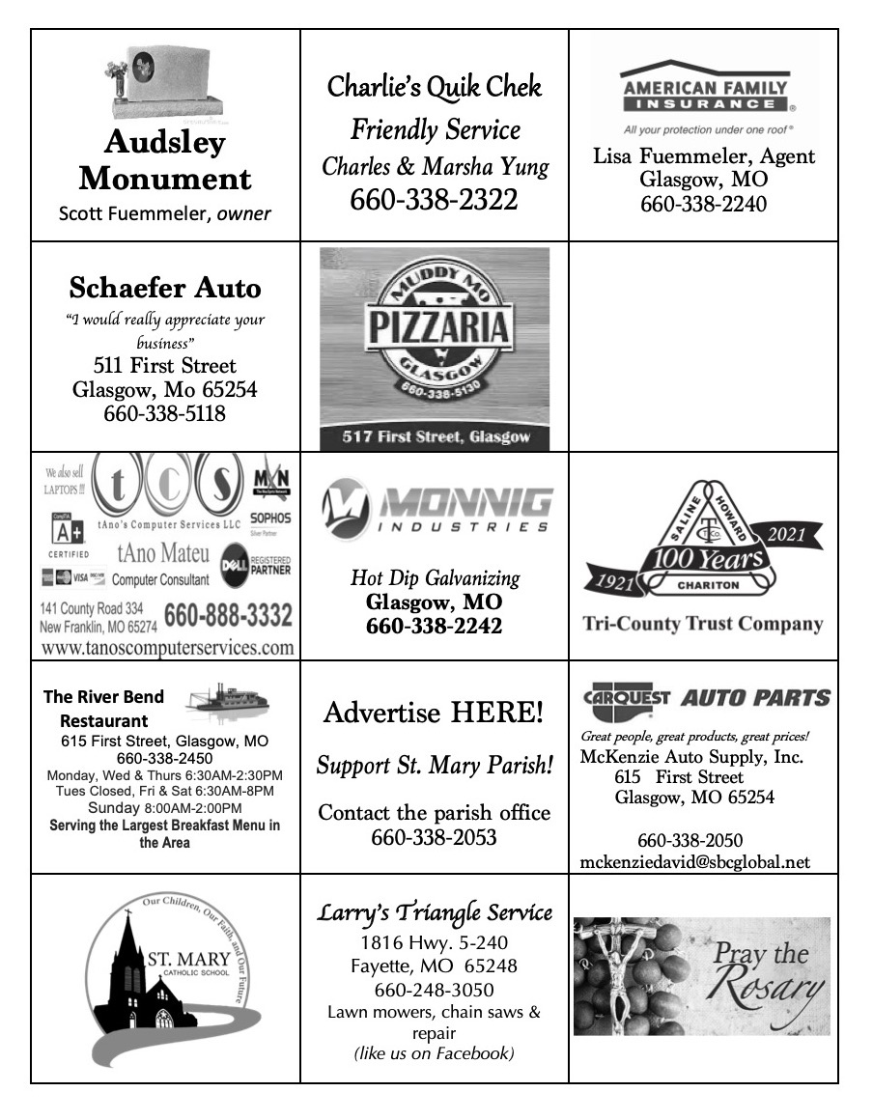

St. Mary Parish Tithing Stewardship
Oct 3, 2021 $12,129.00
Oct 10, 2021 $5,593.00
Oct 17, 2021
Oct 24, 2021
Oct 31, 2021
Total direct deposits
Total for month $17,722.00

Offertory budget goal / month $48,076.92
Weekly goal $12,019.23
(Under) for two weeks ($6,316.46)

Offertory Goal Year-to-date $204,326.91
Offertory year-to-date $145,219.11
(Under) Budget year-to-date ($59,107.80)

STEWARDSHIP – PARISH MINISTRIES
Sat. Oct 30  Rosary  Host Team  Lector  EO Ministers  Choir  Servers  Sun. Oct 31  Rosary  Host Team  Lector  EO Ministers  Choir  Servers | 5:30 PM  Adolph & Diane Barringhaus  Jerome & Kathleen Thies, Kelly Monnig & Luke Moser  Nicholette Lewis  Jenna Lee  Herb Fuemmeler (loft)  Volunteers needed  Parker Monnig  Britton Barringhaus  10:00 AM  Kent & Joyce Monnig  Michael Barringhaus Family  Debbie Johnson  Jenny Westhues  Ryan Monnig (loft)  SMS Choir  Jacob Simpson  Jackson Meyer
PLEASE PRAY FOR THE SICK
Ella Marie Wilson | Jason Monnig
Cindy Wilson Hall | Marvin Crowley
Dena Fitzgerald | Byron Stallo
Nursing Home Residents | All Military personnel and their families
Layla Johnson | Sam Audsley
Nina Bell Schafer | All Shut Ins
Suzanne Freese | Tony Monnig
David F. Monnig | Greg Larm
Sister Jania Keogh | John Murphy
Betty King | Mary McCoy
Tony Holt | Mary Kay Noll
Crystal Aholt | Gwen Brand
Father Paul Hartley | Lucille Vose
Sophia Friedrich | Margie Lewis
Dorothy Colvin | Daniel Stallman
Wilma Christensen | Doris Gibbs
Blake Manken | Rhonda Hammons
Cindy Crowley | Kevin Perry
Stacy Senor | Chance Lackland
Trish Lewis | Sheila Sellmeyer
Joe Fuemmeler | Will Beaman
Daniel Enyeart Michele Aholt
Florence Weber Gary Stallman
St. Mary Parish Capital Campaign
Totals as of October 12, 2021
Pledged - $501,750.49
Goal - $500,000.00
Pledges received - $421,973.95
Yet to Receive - $79,776.54
Thank you!! Your generous support helps us to move forward to keep improving our campus.

       

Bishop McKnight’s October prayer intention for our Local Church is: “For our local church of the Diocese of Jefferson City; that we may become a sign and instrument in the world of the presence of Christ through our communion in charity, faith, and the Eucharist.”

       

PARISH FALL DINNER UPDATES
-- Watch for parish letters and worker cards to come in the mail this week!
-- If you don't receive a worker card and want to work, please contact Jenna Lee or a committee member.
-- Thank you for all the bread donations and for responding so quickly! We have reached our goal and then some.
-- All volunteers are being asked to complete the Virtus Program for the diocese. Please see the information with worker cards for instructions.
-- This year coleslaw will be optional on all orders. Bottled water and tea will be available at time of purchase--for drive-thru only.
-- Pre-orders for in-town deliveries need to be made by Nov. 7th. Please contact Kathleen Thies to place your orders: 338-2409.

       

WELCOME MSGR. FLANAGAN!
Please extend a warm welcome to Msgr. Flanagan from Our Lady of Lourdes in Columbia who is covering this weekend.
Fun Priestly Fact: Msgr. Flanagan baptized Fr. Duncan at Immaculate Conception in Jefferson City when he was the pastor there!
MASS SCHEUDLE UPDATES
- There will not be daily Mass this week (Oct. 25-29), Fr. Duncan will be out of town.
- November 1st, All Saints Day, is a Holy Day, but the US Bishop’s have dispensed from the “Obligation” since it falls on a Monday. We will have Holy Mass at 8:15 AM at St. Mary that morning.
- November 2nd, All Souls Day, we will have Holy Mass at 8:15 AM, followed by the customary procession to the Cemetary. There is also a 6 PM Mass at St. Joseph, Fayette that evening.

       

FALL 2021 CONFIRMATION
Confirmation for our 7th Grade School and CCD kids is rapidly approaching. Information regarding the ceremony was sent home with the candidates. A few things to take note of:
- Retreat: Sunday, November 7th, 12noon to 5 PM at St. Joseph, Fayette in the Parish Hall.
- Rehearsal: following the retreat in St. Joseph Church
- Dress/Other notes: See the sheet that was sent home.
Any questions, please contact Fr. Duncan – jduncan@diojeffcity.org

       

WORD AMONG US BOOKLETS
The November Issues of the Word Among Us Daily Readings & Meditation booklets are available to you in the back of Church! Please take a copy to assist you in your daily prayer life! They are free of charge for these few months, but donations will help us continue to provide these booklets in the future.

CHRISTMAS DECORATIONS
We are attempting to restore an outdoor nativity set and updating Christmas decorations for the interior of the church. If anyone would like to donate for this purpose, please drop your donation into a marked envelope and place it in the offering basket. Any assistance would be appreciated.
STEWARDSHIP COHORT 2
www.diojeffcity.org/stewardship
Stewardship: The grateful response of a Christian disciple who recognizes and receives God’s gifts and shares these gifts in love of God and neighbor.
St. Mary and St. Joseph Parishes are in the ‘second cohort’ of parishes transitioning into becoming fully stewardship parishes. This means that we are joining 20 other Parishes in the diocese this year to begin the process of ‘becoming a full stewardship parish.’ Every single parish will be going through this process, and there are a total of 3 cohorts. This means we are not the first ones to go through the process, but we won’t be the last ones either – ensuring as smooth of a transition as we can possibly hope for.
Practically speaking, what does this mean for you?
- There will be a great reduction in second collections, “fundraising” – aka the “nickel & diming”.
- Cathedraticum will go away (the “diocesan tax”) and instead be replaced by a transparent 10% tithe on all our operational income.
- CSA (Catholic Stewardship Appeal) will turn into CSR (Catholic Stewardship Renewal) – instead of being asked to give a set amount to the diocese, an annual emphasis on renewed stewardship in the Parish will take place.
- Renewed emphasis on Sacrificial giving: of our time, our talents and our treasure in service of our Parish, as stewards of the Parish entrusted to us. Giving out of a need to give back to God, the first fruits rather than leftovers.
- Small Groups will be forthcoming in 2022 – the wonderful opportunity to participate in a small group with other parishioners through a program “Grateful Living” led by RENEW International (details coming soon).
- Fr. Stephen Jones, director of Stewardship for the diocese – covered Masses this past May, and will come back again to cover Masses on April 23/24, 2022.

**SAFE ENVIRONMENT
(VIRTUS) COMPLIANCE**

All Parishioners in every Parish in the Diocese of Jefferson City, at the direction of the Bishop, are required to have the necessary Safe Environment training to be compliant with the Dallas Charter enacted by the USCCB in 2002.

WHO is this for?
- ALL Employees of the Parish/School.
- ALL Parents of children enrolled in our Parish’s Catholic School.
- ALL Parish Volunteers (Lectors, EMHC, Musicians, Fall Dinner, etc.)

WHAT does it require?
- An online Account, registered through www.virtusonline.org
- IF you are brand new to the VIRTUS website, you have the option to attend training IN-PERSON or train through the ONLINE portal. If you elect to train in person, you must set up an online account and sign up for the in-person session you wish to attend. If you need help with this, please contact the Parish Office for an instruction sheet or contact the Diocesan Chancery (573.635.9127).
- IF you already have a VIRTUS account (some parishioners do from 2003 onward), but are inactive, lost your password, aren’t sure about login information, or aren’t sure about what you need to do to “get current” – please contact the Diocesan Chancery (573.635.9127) and ask the receptionist for “help with my VIRTUS account”.
- IF you are NOT an employee, you only need to go through the training once, complete the background check information, and read the Code of Conduct – and you are good for forever! (As long as the diocese is using VIRTUS).
  - There are no “ongoing bulletins” to mess with. It’s a one-and-done.
- IF you ARE an employee, you only need to keep current on the assigned trainings once every couple of years. The monthly bulletins are optional.

IN-PERSON TRAINING OPTIONS
(must register online to attend)
- Wednesday, October 27; 6:30 PM – at St. Joseph, Fayette in the Parish Hall. (~2 hours)
- Sunday, November 7; 1:00 PM – at St. Mary, Glasgow in the School Cafeteria. (~2 hours)

       

ST. MARY SCHOOL NEWS
Mr. Monnig was away at the Diocesan retreat for Principals this week (well-deserved time for rest!), so the school newsletter will be very limited for the bulletin.

Volunteers Needed
Attention basketball and cheer parents. Thanks for those that were able to help out with concessions at our first home basketball game. If you didn’t get your chance Mrs. Thies sent out a document where you can sign up online. We still have some slots available. We appreciate all parents involved with athletics taking their turn as the profit from these concessions will now feed into our athletic fund. Thanks for doing your part. Slots open on 10/26/21, 10/28/21, & 11/09/21.
