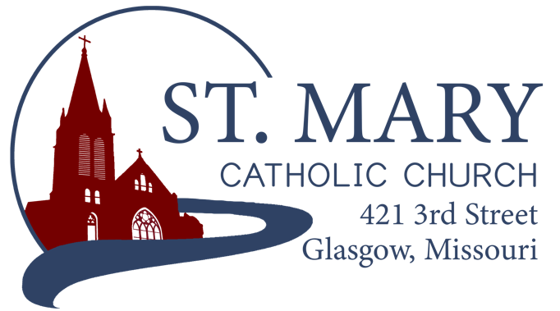

Mission Statement
We, the members of St Mary Parish, profess, practice, and proclaim our faith in Jesus Christ through word, sacraments, education and service.

EMAIL: parishoffice@stmarysglasgow.org
WEBSITE: www.glasgowstmary.com
FACEBOOK: St. Mary Church, Glasgow, MO

St. Mary Parish Office …………… 660-338-2053
St. Mary School Office …………...…… 660-338-2258

Pastor…………………….….….… Fr. Joshua Duncan
School Principal …..…….……… Mr. Kent J. Monnig
Parish Bookkeeper/Secretary…. Wanda Fuemmeler

St. Mary Confessions:
Saturdays 4:00 – 5:15 pm

St. Mary Parish Office Summer Hours:
Tues., Wed., Thurs.: 8 a.m. to 3 p.m.

St. Joseph Parish, Fayette – Schedule
Tuesday ……………. Mass 6:00 PM
Confessions 5:15 to 5:45 PM
Sundays……..……… Mass 8:00 AM
Confessions 7:30 AM
ST. MARY HOLY MASS SCHEDULE
Sat Aug 13  5:30 pm | Deceased members of Vincent & Clara Sellmeyer family†
Sun Aug 14  10:00 am | Deceased members of Jim & Jane Holtwick family†
Mon Aug 15  8:15 am  Tues Aug 16 | Sylvester Sommer†  NO S.J. FAYETTE MASS
Wed. Aug 17  8:15 am | Juliann Barringhaus†
Thurs Aug 18  8:15 am | Father Paul Hartley†
Fri Aug 19  8:15 am | St. Mary School students, faculty & staff
Sat Aug 20  5:30 pm | Marian Sellmeyer†
Sun Aug 21  10:00 am | People of St Mary & St Joseph Parish

St. Mary Parish Tithing Stewardship
Aug. 7, 2022* $ 9,213.00
Aug. 14, 2022* $
Aug. 21, 2022* $
Aug. 28, 2022* $
(below – accrued totals for the month)
ACH Deposits / Blackbaud $ 765.73
Other Offertory (Mail, Office) $ 1,200.00
Total for month $11,178.73

Offertory budget goal / August $48,076.92
Weekly goal $12,019.23

Offertory Goal Year-to-date $72,115.38
Offertory year-to-date $65,906.60
Under budget year-to-date ($6,208.78)
STEWARDSHIP – PARISH MINISTRIES
Sat. Aug. 20  Rosary  Host Team  Lector  EO Ministers  Choir  Servers  Sun. Aug. 21  Rosary  Host Team  Lector  EO Ministers  Choir  Servers | 5:30 pm  Adolph & Diane Barringhaus  Andy, Lindsay & Hudson Kallmeyer, Charlie Monnig  Janet Himmelberg  Jim Hackman  Anna McBride(loft)  Cecilia’s Voice  Robert Auck  Parker Monnig  10:00 AM  Carol Wolz  Barry & Julie Fuemmeler  Chad & Cash Westhues  Cheryl Adams  Joyce Monnig  Kent Monnig (loft)  Rise Up & Rejoice  Lydia Friedrich  Alliyah Monnig

PLEASE PRAY FOR THE SICK
Ella Marie Wilson | Jason Monnig
Cindy Wilson Hall | Byron Stallo
Nursing Home  Residents | All Military personnel  And their families
Dena Fitzgerald | Sam Audsley
Layla Johnson | All Shut Ins
Nina Bell Schafer | Tony Monnig
Suzanne Freese | Greg Larm
Sister Jania Keogh | John Murphy
Betty King | Mary McCoy
Tony Holt | Mary Kay Noll
Sophia Friedrich | Gwen Brand
Dorothy Colvin | Lucille Vose
Wilma Christensen | Margie Lewis
Blake Manken | Daniel Stallman
Cindy Crowley | Doris Gibbs
Trish Lewis | Tim Brooks
Daniel Enyeart | Kevin Perry
Karen Alden | Chance Lackland
Damian Barton | Sheila Sellmeyer
Wayne Aholt | Will Beaman
Charlie Yung  Gloria Courville  Jake Peiffer | Ashley Westhues  Sheldon Fessler  Wilma Bonen

PARISH OFFICE HOURS (THIS WEEK):
TUESDAY, WEDNESDAY, & THURSDAY FROM 8 AM TO 3 PM.
       
ST. MARY CAPITAL CAMPAIGN
Totals as of August 9, 2022
Pledged - $493,790 (98.6%)
Goal - $500,000.00
Pledges received - $458,916 (91.6%)
Yet to Receive - $34,873.00
Thank you!! Your generous support helps us to move forward to keep improving our campus.
       
Bishop McKnight’s August prayer for our Diocese is: “For a new commitment to building an America where children are welcomed, cherished, and cared for; where mothers and fathers are encouraged and strengthened; and where marriage and the family are recognized and supported as the true foundations of a healthy and flourishing society.” 
       
AUGUST STEWARDSHIP PRAYER
Lord Jesus Christ, as we begin to shift our thoughts from summer schedules to the anticipated demands of autumn, teach us to recognize you, and help us follow you amidst our busy lives. Open the Scriptures to us… that we may know you, see you, hear you – in the voices of friends and family, in the ministries of our parish, in the proclamation of the Word, and in the Breaking of the Bread. Teach us to be good stewards, that we may use your gifts wisely and care for all those you place in our path. Encourage us when we are overwhelmed. Strengthen us when we are frightened. Challenge us when we are complacent. Help us make our August transition a time of spiritual renewal, hope and action: to proclaim the Gospel in our words and in our deeds. Amen.
       
There will be a Monday (8:15am) Mass for the Holy Day – The Assumption of the Blessed Virgin Mary. It is not a day of obligation this year since it falls on a Monday. It is a holy day of opportunity!
There will not be a Tuesday evening daily Mass this week (the 16th) in Fayette – there is a Diocesan Deanery meeting that evening.
       
EMAIL SCAMS – “SPOOFING”
Email spoofing is becoming all too common these days. “Email spoofing is a technique used in spam and phishing attacks to trick users into thinking a message came from a person or entity they either know or can trust. In spoofing attacks, the sender forges email headers so that client software displays the fraudulent sender address, which most users take at face value.” Recently, someone has attempted to “spoof” Fr. Duncan’s diocesan email – so it looks like it came from his email, but when you it reply, it sends it to a random, different email. If you receive a suspicious email, it is very important that you DO NOT reply to it. (Fr. Duncan will never ask for “emergency help” through an email at 11pm at night) – Feel free to contact the Parish Office if you have any questions or if you think you’ve received a suspicious email.
      
PARISH EVENTS – COMING UP!
*Sunday, August 14 – “Back to School Splish Splash” at the Glasgow Pool. Join us for fun, fellowship, and swimming from 7-9pm. All Parishioners are welcome to attend this free event.

*Sunday, August 21 – “Youth Pancake Breakfast” – this is not a fundraiser, but a great social opportunity with our youth! This will be held after the morning Mass in the SMSchool Cafeteria.

*Sunday, August 28 – “Parish Potluck” after the morning Mass at the Knights of Columbus Hall / 11:15 AM. Fried Chicken and drinks will be provided. (A-L) = please bring a side dish. (M-Z) = please bring a dessert.

*Sunday, October 2 – “Fellowship Sunday” – Take a few minutes after the morning Mass to enjoy pastries, juice, and coffee with your parish family! Join us for this opportunity to connect with each other and enjoy a treat. Weather-permitting, this will take place in the front of Church.
      
PILGRIMAGE OPPORTUNITYS!

Holy Land – February / March 2023
Pilgrimage to the Holy Land with Fr. Matthew Flatley, February 27 - March 8, 2023. Information Gathering Meeting on Wednesday, September 7, 2022 @ 7 pm at Immaculate Conception Church in Jefferson City. Contact Fr. Matt mflatley@diojeffcity.org or 573-202-3590.

National Shrine – Laurie – Sept. 2022
The National Shrine of Mary, Mother of the Church invites all for a pilgrimage with speaker Kathleen Lindemann on SEPTEMBER 17, 2022. Kathleen is a dynamic Catholic evangelist. Taking everyday life situations, she weaves the Joy of the Gospel into a practical application. Listeners will learn how to unleash the Gospel in their own lives as Kathleen leads them to realize how they can walk in the light of Christ. Kathleen will be speaking on Mary's "Yes" Can Be Our "Yes" too and Unlocking the Virtues to a Joyous Life. The pilgrimage day starts at 8:30 a.m. and includes the two speaker sessions, Confessions, Adoration, Benediction, Rosary and Divine Mercy Chaplet culminating in Mass at 4:30 p.m. Lunch is provided. The Shrine is located at 176 Marian Drive, Laurie, MO 65037. Call 573.374.6279 for more info.
      
CAMPUS PROJECTS
As of August 11, 2022
RETAINING WALL COLLAPSE
All State Consultants (an engineering firm out of Columbia, MO) is working with us on designing and developing plans for a new retaining wall that will last. This process is not cheap at all (but very necessary). It involves both civil and geotechnical engineers coming up with a comprehensive design based on the height of the wall needed, the steep slope-grade, and the soil composition. The estimated cost on the design alone will be $23,600. Our insurance company was contacted to see if we had any sort of coverage for the failure of the wall. We do not; it was asked that the original contractor contact their insurance. We are in current talks with our insurance company about the possibility of future coverage options. There are still many unknowns at this point; it is a very complex project to fix correctly. Caution tape has been placed around the wall, and we ask that no one go near the wall for their safety.
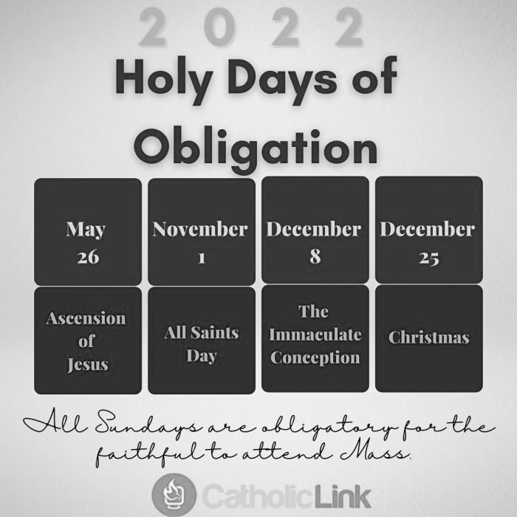
       
GENERAL DIOCESE OF JC - FYI
Love and Life Retreat for Couples Sept. 3 - Love and Life is a one-day retreat where couples explore the truth and beauty of marriage and God’s plan for it. It will be held Sept. 3, 8:30 am to 5 pm, at the Chancery in Jefferson City. Based on Marriage: Love and Life in the Divine Plan by the US bishops, this retreat will help couples renew their bonds through presentations and periods of prayer. It has helped hundreds of couples reconnect and appreciate each other, their relationship, and their marriage. This retreat is open to all couples (married, engaged & unmarried). Registration for this event is required and can be found on the Diocesan website.

Catholic Schools & Stewardship - It is the vision that Catholic school education be accessible to all Catholic families. However, all our Catholic families do have a choice before them: will they strive to live as active stewards in their parish? Will they commit to attending Mass on weekends and Holy Days? Will they pledge and stay current on a commitment of time and treasure to support the work of the parish? Every single Catholic person in our diocese is being called to live as an active steward. We are asking all parishioners to live as active stewards:
- Attend Sunday Mass and Holy Days of Obligation
  - At St. Mary or St. Joseph Parishes
- Participate regularly in the sacraments (the sacramental life of the Church)
  - Reconciliation, Baptism of your Children, etc.
- Actively participate in the life of the parish / school
  - Volunteer your time and talents
- Sacrificially give to support the ministries of the parish
  - Treasure / Tithing – 10% Tithe is biblical (8% to your parish and 2% to charity of your choice)

Seminarians for 2022-2023 School Year – We currently have 8 seminarians studying for our Diocese. Please pray for an increase in Holy Vocations to the Priesthood so that the Sacraments & Holy Mass may continue in our parishes!
- Christopher Hoffmann (Theology 3)
- Philip Novotny (Theology 3)
- Gregory Clever (Theology 2)
- Jacob Hartman (Theology 1)
- Bryce Smith (Pre-Theology)
- Shane Kliethermes (College 4)
- Gage Neisen (College 3)
- John Paul McGuire (College 2)
       
ST. MARY SCHOOL NEWS

OPEN HOUSE – INVITE!
You are invited to St. Mary’s School for an open house after the 10 AM Sunday Morning Mass this weekend! All of our teachers and staff have been very hard at work making sure the school is beautiful and ready to go for this year.
- There will be sign-ups for afterschool care at the Open House
- 4th – 8th graders will also be able to sign-up to be an Altar Server for weekend (and school) Masses.
FIRST DAY OF SCHOOL
The first day of school is Thursday, August 18th, with a 1 PM dismissal.

