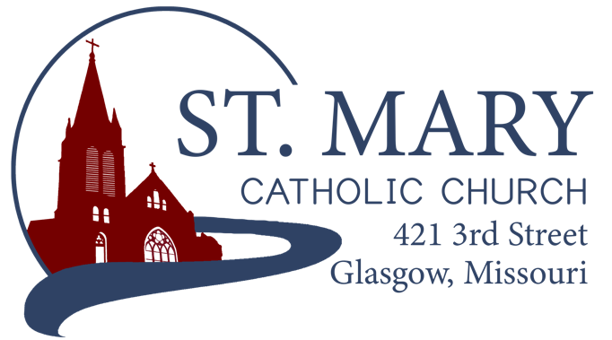
Mission Statement
We, the members of St Mary Parish, profess, practice, and proclaim our faith in Jesus Christ through word, sacraments, education and service.

EMAIL: parishoffice@stmarysglasgow.org
WEBSITE: www.glasgowstmary.com
FACEBOOK: St. Mary Church, Glasgow, MO

St. Mary Parish Office …………… 660-338-2053
St. Mary School Office …………...…… 660-338-2258

Parochial Administrator .….…… Fr. Joshua Duncan
School Principal …..…….……… Mr. Kent J. Monnig
Parish Bookkeeper/Secretary…. Wanda Fuemmeler

St. Mary Confessions:
Saturdays 4:00 – 5:15 pm

St. Mary Parish Office Hours:
Mon., Tues., Thurs.: 8 a.m. to 3 p.m.

St. Joseph Parish, Fayette – Schedule
Tuesday ……………. Mass 6:00 PM
Confessions 5:15 to 5:45 PM
Sundays……..……… Mass 8:30 AM
Confessions 7:45 to 8:15 AM
ST. MARY HOLY MASS SCHEDULE
Sun July 4  10:00 am | People of St Mary & St Joseph Parish
Tues July 6 (6:00 pm) | S.J. FAYETTE MASS
Wed July 7  8:15 am | Living & Deceased members of Daughters.of Isabella
Thurs July 8  8:15 am | Father Hartley - healing
Fri July 9  8:15 am | Ethan Fuemmeler†
Sat July 10  5:30 pm | Barbara Sellmeyer & deceased family members†
Sun July 11  10:00 am | Clarence & Marcella Himmelberg†
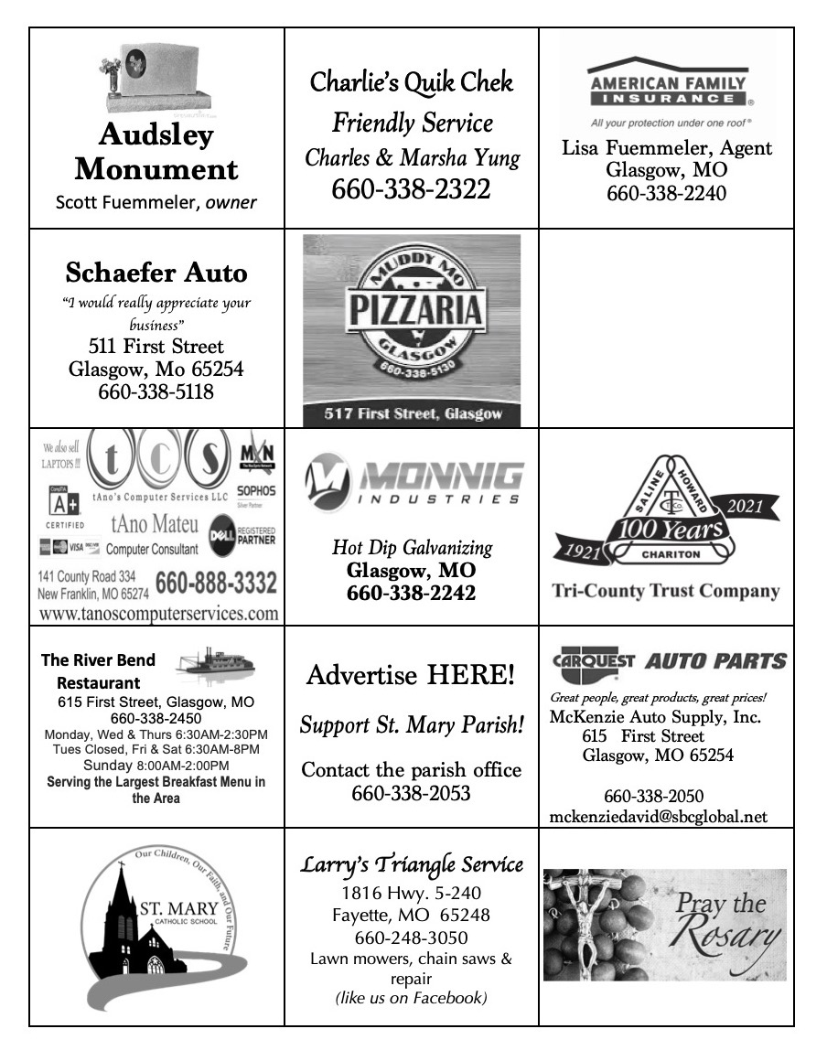

St. Mary Parish Tithing Stewardship

June 6, 2021 $8,150.00
June 13, 2021 $5,435.00
June 20, 2021 $5,350.00
June 27, 2021 $7,151.00
Total direct deposits $4,001.82
Total for month $30,087.82

Offertory budget goal / month $44,250.00
Weekly goal $10,211.54
(Under) for June 2021 ($14,162.18)

STEWARDSHIP – PARISH MINISTRIES
Sat. July 10  Rosary  Host Team  Lector  EO Ministers  Choir  Servers  Sun. July 11  Rosary  Host Team  Lector  EO Ministers  Choir  Servers | 5:30 PM  Marjorie Thies  Charlie & Jacob Monnig  Erin Witte  Cindy Crowley  Mike Crowley (loft)  Seasonal Singers  Bridger Ewings  Luke Moser  10:00 AM  Carol Wolz  Chad Fuemmeler Family  Debbie Johnson  Jenny Westhues  David Brucks (loft)  SMS Choir  Aly & Nathan Prentzler
PLEASE PRAY FOR THE SICK
Ella Marie Wilson | Jason Monnig
Cindy Wilson Hall | Bernie Korte
Dena Fitzgerald | Byron Stallo
Nursing Home Residents | All Military personnel and their families
Layla Johnson | Sam Audsley
Nina Bell Schafer | All Shut Ins
Suzanne Freese | Tony Monnig
Catherine Schaefer | Greg Larm
David F. Monnig | John Murphy
Dr. W.G. Marshall | Sheila & Herb Sellmeyer
Sister Jania Keogh | Mary McCoy
Marian Sellmeyer | Mary Kay Noll
Billy Sickman | Gwen Brand
Nellana DeGraff | Emmett Schroeder Sapp
Sophia Friedrich | Lucille Vose
Dorothy Colvin | Margie Lewis
Karen Gebhardt | Daniel Stallman
Blake Manken | Inez Wachter
Cindy Crowley | Doris Gibbs
Stacy Senor | Rhonda Hammons
Betty King | Kevin Perry
Father Paul Hartley | Tony Holt

St. Mary Parish Capital Campaign
Totals as of June 29, 2021
Pledged - $367,332.00
Goal - $500,000.00
Pledges received - $274,180.00
Thank you!! Your generous support helps us to move forward to keep improving our campus.
       

Daughters of Isabella – Update
The Our Lady of Fatima Circle of the Daughters of Isabella met on Thursday, June 10 with the D of I State Regent, Maryann Schuster. Due to a lack of membership and other reasons the group voted to disband at this time. The circle was started in January of 1950 with Joanne Meyer and Lois Brucks being charter members, so it was with great sadness that this decision was made. If you are a current member and wish to transfer your membership to another circle like Boonville or Marshall, please contact Cheryl Adams immediately. All of the remaining funds have been donated to St. Mary’s Church (votive candle fund) and St. Mary’s School.

       

Heading into the Summer Season
Please remember to still drop off your Parish Offering Envelopes this summer (in person, mail, office, etc.), even if you might be going out of town. Our Parish greatly relies on your support and generosity to keep everything running smoothly, even during the summer months. During these summer months we still pay our (larger) bills – including salaries (~$50,000/month), health insurance (~$16,000/month), and other general operating expenses. Thank you for your generous support and helping our Parish to keep the mission alive and moving forward!

SUMMER TRAVELING?
Traveling this Summer? Check out the local Parishes’ Weekend Mass times where you are going! Here are some examples:
Lake of the Ozarks:
- Our Lady of the Lake, Osage Beach
  - Saturday – 5:00pm
  - Sunday 8am & 10am
- St. Patrick, Laurie
  - Saturday – 4:30pm & 8pm
  - Sunday – 8:30pm & 10:15am
- St. Anthony, Camdenton
  - Saturday – 5pm
  - Sunday – 7:30am & 10am
Branson:
- Our Lady of the Lake
  - Saturday – 5pm
  - Sunday – 8am & 10:30am

Check out: masstimes.org

PRAYER FOR A GOOD VACATION
from www.catholicholycards.org
Heavenly Father, when your work of creation was complete, you rested. Lord, during my vacation from the cares and burdens of everyday life, please renew me physically, mentally, and spiritually. Help me to slow down and take delight in your magnificent creation and in all those I’ll share this time with. Help me to embrace this period of leisure and regain strength to continue my journey through life. By leaving my work behind for these days, may I focus my gaze on you, and reflect on what is important in life. Remind me to pray each day since I’m taking this vacation with you, not away from you. May you keep me safe in my travels and protect me from all harm. May I be revitalized and refreshed so I may return to carry out my daily responsibilities with joy and newfound enthusiasm. Amen.

Bishop McKnight’s July prayer intention for our Local Church is: “We pray for our country at this moment in history, that the dreams of life, liberty and happiness remain in our hearts as well as the desire that we will always be one nation under God.”

       

From Father Hartley:
Chemo went smoothly so far. I only have to go once every two weeks to get two different types of medicine now. I am so grateful for your cards and prayers.
       

Nursing Home/Homebound Visits
Beginning in July 2021, our Homebound Extraordinary Ministers of Holy Communion will be making visits to our Nursing Home, Assisted Living, and Homebound Parishioners. To ensure that we have an accurate list, please notify the Parish Office if you know of anyone who would like a visit.

       

Constellation Gas Bill AND
Bell tower Insurance Claim – Update
Through a great spirit of generosity, we had 26 families donate towards paying off our Natural Gas bill (from the month of February when prices skyrocketed nationwide). The money we have collected is being held in a separate “gift” account until we receive clearance from our Diocesan lawyers that the “details” have been worked out for us to exit our contract with Constellation. We would then be able to fully pay off our bill and switch the Church and the School over to exclusively using Liberty (which the Office/Rectory is exclusively on currently).
Any money that might be left over from this effort will then be used to pay towards our (unexpected!) $2,000 insurance claim deductible to help repair the interior of the bell tower that was damaged by water back in April 2021. We have been working closely with the diocese and our insurance company to fix the source of the problem (a rubber membrane where the roof meets the bell tower), as well as working towards repair / replace any interior parts damaged (Plaster, ceiling, carpet/flooring, painting, etc.)

       

ST. MARY SCHOOL NEWS
School office Hours will typically be from 9am – 12 noon Tuesday through Thursday. Please contact the school office if you need assistance to ensure someone will be in the office to assist you.

       

Thank You!

Thanks to Kent & Joyce Monnig for trimming all of the shrubs and bushes in front of the rectory and the church!

       

Knights of Columbus

To the St. Mary's Parish, the Satolli council 1752 Knights of Columbus, Fr. Duncan and Fr. Hartley,

Thank you for another successful fraternal year. We could not have done it without your support and prayers. The last two years have seen many challenges, but our council has persevered and is as strong as ever.
Starting July 1st, council 1752 has a new Grand Knight. I would like to congratulate Joe Morris on his election to lead the council. I know he'll do an excellent job.
Coming up in July, our council will be hosting the new Exemplification of Charity, Unity and Fraternity. This will take the place of the 1st, 2nd and 3rd degrees of the past to come into full Knighthood. All practicing Catholic men ages 17.5 years old and up are welcome to join our order. In addition to those candidates, Knights that have only received their 1st degree are encouraged to participate in the exemplification to become a full Knight. The exemplification will be held after mass in the church, and anyone is welcome to watch the ceremony. The first date is scheduled for July 25th.
If interested in joining the Knights, please contact myself, Justin Friedrich 573-999-1467 or go to kofc.org/joinus

       

