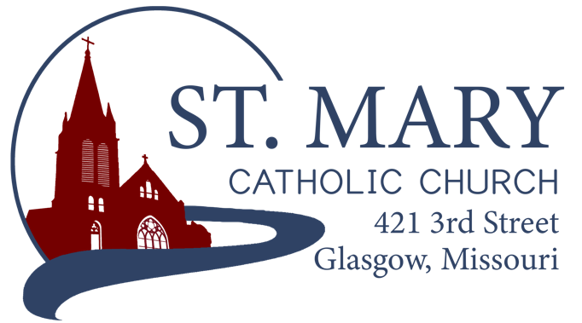

Mission Statement
We, the members of St Mary Parish, profess, practice, and proclaim our faith in Jesus Christ through word, sacraments, education and service.

EMAIL: parishoffice@stmarysglasgow.org
WEBSITE: www.glasgowstmary.com
FACEBOOK: St. Mary Church, Glasgow, MO

St. Mary Parish Office …………… 660-338-2053
St. Mary School Office …………...…… 660-338-2258

Parochial Administrator .….…… Fr. Joshua Duncan
School Principal …..…….……… Mr. Kent J. Monnig
Parish Bookkeeper/Secretary…. Wanda Fuemmeler

St. Mary Confessions:
Saturdays 4:00 – 5:15 pm

St. Mary Parish Office Summer Hours:
Tues., Wed., Thurs.: 8 a.m. to 3 p.m.

St. Joseph Parish, Fayette – Schedule
Tuesday ……………. Mass 6:00 PM
Confessions 5:15 to 5:45 PM
Sundays……..……… Mass 8:00 AM
Confessions 7:30 AM
ST. MARY HOLY MASS SCHEDULE
Sat July 2  5:30 pm | David Himmelberg†
Sun July 3  10:00 am | People of St Mary & St Joseph Parish
Mon July 4  9:00 am | William & Pauline Schafer†
Tues July 5 | S.J. FAYETTE MASS
Wed. July 6  8:15 am | Donald Himmelberg†
Thurs July 7  8:15 am | Rose Weber†
Fri July 8  8:15 am | Earl Freese†
Sat July 9  5:30 pm | Keith Costello†
Sun July 10  10:00 am | Adolph & Ida Barringhaus†

St. Mary Parish Tithing Stewardship
June 5, 2022 $7,875.00
June 12, 2022 $7,497.00
June 19, 2022 $4,765.00
June 26, 2022 $8,221.00
Total direct deposits $3,915.72
Total for month $32,273.72

Offertory budget goal / month $48,076.92
Weekly goal $12,019.23
(Under) for month ($15,803.20)

Offertory Goal for fiscal year $625,000.00
Offertory final for fiscal year $533,911.82
(Under) Budget for fiscal year ($91,088.18)
STEWARDSHIP – PARISH MINISTRIES
Sat. July 9  Rosary  Host Team  Lector  EO Ministers  Choir  Servers  Sun. July 10  Rosary  Host Team  Lector  EO Ministers  Choir  Servers | 5:30 pm  Janice Watts  Molly Monnig Family  Charlie Monnig  Janet Himmelberg  Cindy Crowley  Mike Crowley(loft)  Seasonal Singers  Michael & Dylan Johnson  10:00 AM  Bill Daily  Cheryl Adams, Brandon Fuemmeler, Jenny Westhues, Joe Morris  Sally Fuemmeler  Joyce Monnig  Kent Monnig (loft)  SMS Choir  Tyler & Ryleigh Barringhaus
PLEASE PRAY FOR THE SICK
Ella Marie Wilson | Jason Monnig
Cindy Wilson Hall | Byron Stallo
Nursing Home  Residents | All Military personnel  And their families
Dena Fitzgerald | Sam Audsley
Layla Johnson | All Shut Ins
Nina Bell Schafer | Tony Monnig
Suzanne Freese | Greg Larm
Sister Jania Keogh | John Murphy
Betty King | Mary McCoy
Tony Holt | Mary Kay Noll
Sophia Friedrich | Gwen Brand
Dorothy Colvin | Lucille Vose
Wilma Christensen | Margie Lewis
Blake Manken | Daniel Stallman
Cindy Crowley | Doris Gibbs
Trish Lewis | Rhonda Hammons
Daniel Enyeart | Kevin Perry
Karen Alden | Chance Lackland
Damian Barton | Sheila Sellmeyer
Wayne Aholt | Will Beaman
Charlie Yung  Gloria Courville | Tim Brooks  Ashley Westhues

NEW PARISH OFFICE HOURS FOR THE SUMMER:
TUESDAY, WEDNESDAY, & THURSDAY FROM 8 AM TO 3 PM.
       
ST. MARY CAPITAL CAMPAIGN
Totals as of June 8, 2022
Pledged - $490,364.36 (98%)
Goal - $500,000.00
Pledges received - $452,766.36 (90%)
Yet to Receive - $37,598.00
Thank you!! Your generous support helps us to move forward to keep improving our campus.
       
Bishop McKnight’s July prayer intention for our Local Church is: “For our nation, for the integrity of our judicial system, and that all branches of government be dedicated to seeking the common good and protecting the dignity and rights of the human person, from conception to natural death.” 
       
JULY STEWARDSHIP PRAYER
Gracious God, You sent your Son to proclaim the Good News, inspire us in faith and show us the way to be good stewards of Your abundant gifts.
In this month of July dedicated to the Most Precious Blood of Jesus, grant us the wisdom to recognize that through his gift of the Eucharist there is but one cup of covenant and communion with Christ and each other. Through the Eucharist, give us the courage to be good stewards of Christ’s presence to others in our words and our deeds. And through your Spirit teach us to live, no longer for ourselves, but in Christ Jesus who lives and reigns with You and the Holy Spirit, God forever and ever. Amen
       
THANK YOU – KofC!
A huge thank you to the Knights of Columbus who have renewed our Parish’s Formed.org subscription for this coming year. If you haven’t yet signed up – it’s free! formed.org/signup
       
4th of JULY MASS (MONDAY)
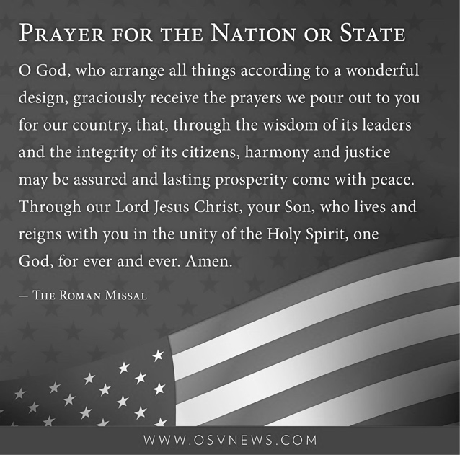
We will have Holy Mass on Monday, July 4 (next week) at 9:00 AM. Please come and start your morning off with prayer and pray for our country!
       
TOTUS TUUS – (“Totally Yours”)
A tremendous thank you to all who have helped organize, provide meals for our missionaries, and volunteer to make our Totus Tuus week a great success. We look forward to having the Totus Tuus program back next year!
       
JULY 16 PILGRIMAGE – LAURIE
The National Shrine of Mary, Mother of the Church invites all for a pilgrimage on July 16 with the nationally acclaimed speaker, television contributor, radio host and life activist Deby Sansone Schlapprizzi. Deby will be speaking on “Our Lady, Queen of Splendor” and “Live Your Splendor, Acknowledge the Truth, Radiate Your Faith.” The pilgrimage day starts at 8:30 a.m. and includes the two speaker sessions, the sacrament of Reconciliation, eucharistic adoration, benediction, Rosary and the Divine Mercy Chaplet culminating in Mass at 4:30 p.m. Lunch is provided. The Shrine is located at the Lake of the Ozarks, 176 Marian Drive, Laurie, MO 65037. Call 573-374-6279 for more information.
       
STEWARDSHIP AND LEISURE TIME – A REFLECTION
Maybe we are not in a position to take too much time off, but all of us can resonate with the need to really “get away” from work or the daily grind or
the constant demands of social media. Even the Gospels suggest that good stewardship of our bodies, minds and souls obliges us to get away on a regular basis (see Luke 5:16).
As Christian stewards, we aren’t just encouraged, but obligated to consider how we approach our stewardship of leisure time. Stewards are aware of their need to be busy doing God’s work, but often forget that down time is equally important to spiritual growth. Leisure time, whether it’s our evenings, our weekends, or our vacation, provides spiritual, physical, mental, and emotional recharging. Leisure is necessary for human wholeness. Leisure reconnects us to the wider mysteries of our world and our God. It helps us daydream, imagine, pray. It refreshes our spirit.
Today, connectivity has become almost an obsession. People check their emails, their messages, and calls with alarming repetitiveness. Accidents, both pedestrian and automobile, happen because people can’t put down their phones. Employers expect their workers to be available for evening emails. The lines between work and free time increasingly blur, as do the lines between solitude and always being present “online.” We can’t imagine putting aside screens for a two-week vacation. But we must give ourselves time to renew and recharge, not just two weeks of the year, but each day and each week.
July offers an opportunity to reconnect with the rhythms of God and nature. We need to take time off from screens and phones, and practice giving undivided attention to the things before us. When we pray, we commit time and silence. When we enjoy time with our friends and family, we practice being totally present. When we sit on the patio or at the beach, we give ourselves wholly to the wind or the waves. Be a good steward of your body, mind and soul. Don’t overschedule your time off. Listen to the quiet whisper of God encouraging you to relax.

PLANNING SUMMER TRAVELING?
Are you traveling this Summer? Check out the local Parishes’ Weekend Mass times where you are going! Here are some examples:
Lake of the Ozarks:
- Our Lady of the Lake, Osage Beach
  - Saturday – 5:00pm
  - Sunday – 8am & 10am
- St. Patrick, Laurie
  - Saturday – 4:30pm & 8pm
  - Sunday – 8:30am & 10:15am
- St. Anthony, Camdenton
  - Saturday – 5pm
  - Sunday – 7:30am & 10am
Branson:
- Our Lady of the Lake
  - Saturday – 5pm
  - Sunday – 8am & 10:30am

Check out: masstimes.org for other parishes

PRAYER FOR A GOOD VACATION
from www.catholicholycards.org
Heavenly Father, when your work of creation was complete, you rested. Lord, during my vacation from the cares and burdens of everyday life, please renew me physically, mentally, and spiritually. Help me to slow down and take delight in your magnificent creation and in all those I’ll share this time with. Help me to embrace this period of leisure and regain strength to continue my journey through life. By leaving my work behind for these days, may I focus my gaze on you, and reflect on what is important in life. Remind me to pray each day since I’m taking this vacation with you, not away from you. May you keep me safe in my travels and protect me from all harm. May I be revitalized and refreshed so I may return to carry out my daily responsibilities with joy and newfound enthusiasm. Amen.
       
CURSILLO WEEKEND
Socrates said that an un-examined life is not worth living. Yet, in order to do this, one has to deliberately carve out a block of time to study oneself and the world with a goal of becoming a more balanced, better human being. Making a Cursillo Weekend is a once-in-a-lifetime opportunity to examine one’s life and figure out what is truly important. Cursillo is a Spanish word (pronounced koor-SEE-yo); it is a short course for all adult Catholics that emerged in Spain and quickly spread through most of the world. It involves spending an extended weekend in a quiet and reflective environment with other Catholics guided by a priest, a deacon and other laity. This team provides for your spiritual and physical needs while you explore the question, WHAT IS A CATHOLIC LIFE WELL-LIVED? Fortunately, the next Cursillo weekends will be held in Columbia, Missouri. Here are the dates:
* Men: starts the evening of July 14-July 17th
* Women: starts the evening of August 4 -August 7th
Contact Tammy McMillan 660-728-9936 with any questions and to request an application to make your Cursillo weekend.
       
ST. MARY SCHOOL NEWS

PRESCHOOL 2022-2023 UPDATES!
WE ONLY HAVE 3 SLOTS LEFT FOR PRESCHOOL! We currently have 17 little ones enrolled for this upcoming school year – drawing from the following communities: Glasgow, Fayette, Salisbury, and New Franklin. We are excited for the future of St. Mary Catholic School serving all of Howard County – and beyond!

AFTERSCHOOL CARE – 2022-2023
Registration forms will be soon available. Registration is monthly for a discounted rate, or there will be a regular “drop-in” daily rate, provided the space and staff are availableLook for the forms with more information coming soon! If you or someone you know would like to work – it is a paid position, and the hours would be roughly 2:45pm – 5:45pm (M-F). Please contact the School Office.

