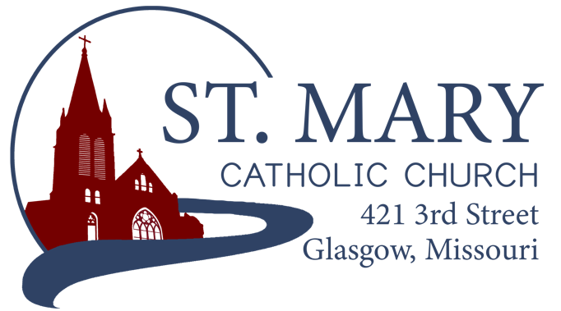

Mission Statement
We, the members of St Mary Parish, profess, practice, and proclaim our faith in Jesus Christ through word, sacraments, education and service.

EMAIL: parishoffice@stmarysglasgow.org
WEBSITE: www.glasgowstmary.com
FACEBOOK: St. Mary Church, Glasgow, MO

St. Mary Parish Office …………… 660-338-2053
St. Mary School Office …………...…… 660-338-2258

Parochial Administrator .….…… Fr. Joshua Duncan
School Principal …..…….……… Mr. Kent J. Monnig
Parish Bookkeeper/Secretary…. Wanda Fuemmeler

St. Mary Confessions:
Saturdays 4:00 – 5:15 pm

St. Mary Parish Office Hours:
Mon., Tues., Thurs.: 8 a.m. to 3 p.m.

St. Joseph Parish, Fayette – Schedule
Tuesday ……………. Mass 6:00 PM
Confessions 5:15 to 5:45 PM
Sundays……..……… Mass 8:00 AM
Confessions 7:30 AM
ST. MARY HOLY MASS SCHEDULE
Sat April 30  5:30 pm | Gilbert and Mary Speichinger†
Sun May 1  10:00 am | People of St Mary & St Joseph parish
Tues May 3  (6:00 pm) | S.J. FAYETTE MASS
Wed. May 4  8:15 am | Mervin Ortego & Family†
Thurs May 5  8:15 am | Aileen Thies†
Fri May 6  8:15 am | Deceased members of Vincent & Clara Sellmeyer family†
Sat May 7  5:30 pm | David Himmelberg†
Sun May 8  10:00 am | Billy Nodder†
St. Mary Parish Tithing Stewardship
April 3, 2022 $10,759.00
April 10, 2022 $8,391.00
April 17, 2022 $6,191.00
April 24, 2022 $5,938.00
Total direct deposits $3,972.33
Total for month $35,251.33

Offertory budget goal / month $48,076.92
Weekly goal $12,019.23
(Under) for month ($12,825.59)

Offertory Goal Year-to-date $528,846.12
Offertory year-to-date $469,956.41
(Under) Budget year-to-date ($58,889.71)
STEWARDSHIP – PARISH MINISTRIES
Sat. May 7  Rosary  Host Team  Lectors  EO Ministers  Choir  Servers  Sun. May 8  Rosary  Host Team  Lector  EO Ministers  Choir  Servers | 5:30 pm  Adolph & Diane Barringhaus  Nick & Megan Meyer family  Megan Watts  Dan Thies  Anna McBride(loft)  Cecilia’s Voice  Bridger Ewings  Kamryn Kottman  10:00 AM  Carol Wolz  Michael Barringhaus family  Teyha Sellmeyer  Whitney Hackman  Cheryl Adams  Bill Daily (loft)  Rise Up & Rejoice  Kaitlyn & Addisyn Monnig
PLEASE PRAY FOR THE SICK
Ella Marie Wilson | Jason Monnig
Cindy Wilson Hall | Byron Stallo
Nursing Home  Residents | All Military personnel  And their families
Dena Fitzgerald | Sam Audsley
Layla Johnson | All Shut Ins
Nina Bell Schafer | Tony Monnig
Suzanne Freese | Greg Larm
Sister Jania Keogh | John Murphy
Betty King | Mary McCoy
Tony Holt | Mary Kay Noll
Sophia Friedrich | Gwen Brand
Gary Stallman | Lucille Vose
Dorothy Colvin | Margie Lewis
Wilma Christensen | Daniel Stallman
Blake Manken | Doris Gibbs
Cindy Crowley | Rhonda Hammons
Trish Lewis | Kevin Perry
Daniel Enyeart | Chance Lackland
Karen Alden | Sheila Sellmeyer
Damian Barton | Will Beaman
Wayne Aholt | Tim Brooks

ST. MARY CAPITAL CAMPAIGN
Totals as of April 4, 2022
Pledged - $488,664.36 (97.7%)
Goal - $500,000.00
Pledges received - $447,936.36 (89.6%)
Yet to Receive - $40,728.00
Thank you!! Your generous support helps us to move forward to keep improving our campus.
       
Bishop McKnight’s May prayer intention for our Local Church is: “For all expecting mothers, biological and adoptive; that through the intercession of Mary, Mother of the church, they may prepare for the new life in the womb and may receive the support of a nurturing community of faith in the raising of their children.” 
       
2021-2022 CATHOLIC
STEWARDSHIP APPEAL (CSA)
Totals as of April 28, 2022
- Parish Goal = $13,260
- $ Received = $13,280 (100% of goal)
- $ Committed = $14,200 (106% of goal)
Thank you to all who have given – since we reached our Parish goal, we will receive 10% of our goal back + 90% back of above our goal as a rebate check! ALL pledges are asked to be fulfilled by JUNE 15, 2022. Thank you!!
       
COMMUNION VISITS – NURSING HOME & HOMEBOUND
St. Mary Parish has a team who regularly provide visits to our Catholic Parishioners who are in the Nursing Home / Assisted Living, those who have just had surgery and are at home from the hospital, or those who might be homebound. Please let us know if you know of someone who would like a visit & Holy Communion brought to them. The Sacraments of Reconciliation and Anointing of the Sick are also able to be provided upon request. Contact the Parish Office or Mr. David Brucks (660-728-2462) to keep us updated on anyone wishing to have a visit, or if you would like to volunteer for this wonderful ministry.
CONGRATULATIONS!
Congratulations to our 2nd Graders who are making their First Holy Communion this weekend: Nina Auck, Charleigh Barringhaus, Abigail Elson, Olivia Ewings, Frank Flaspohler, Sophia Friedrich, Taytum Fuemmeler, Olivia Goodwin, Bennett Meyer, Clark Monnig, Cruze Monnig, Renae Monnig, Jayden Reeves, Easton Shannon, Rylan Vroman, and Breanna Yung. We pray that this will be the first of many, many more to come. May our Eucharistic Lord bless and keep you close to himself always!
       
EASTER 2ND COLLECTION
Each year, the parishes of our diocese are assessed an amount in various categories to support the mission of the local Church. One of those is for the support of Infirmed Priests who have served our local Church. This ’21-’22 FY, our Easter Assessment is $4,992.00. Our 2nd Collection on Easter, combined with the other specific envelopes received so far totaled $2,755. This is about 55% of what we were assessed. Whatever the 2nd Collection does not raise, we have to cover out of the regular operational budget. We greatly appreciate your generosity! If you missed the 2nd collection, but would still like to donate, please put your donation in a specifically marked envelop and drop it in the collection basket or give it to the Parish Office. Thank you!
       
CATHOLIC WOMENS MINISTRY
The Diocese Women’s Ministry invites Catholic women throughout our diocese to complete an online survey. All information gathered will be used to discern proper resources, educational formation opportunities, programs and events specifically targeted to women in your parish and throughout the diocese. The results of the survey will be shared with pastors and parish women’s ministry representatives. To complete the survey online, enter the following link into your browser https://diojeffcity.org/womensministrysurvey/ or visit the women’s ministry website page https://diojeffcity.org/womens-ministry/ For opportunities to get involved in the ministry, please contact your parish women’s ministry representative, Cheryl Adams or LeAnn Korsmeyer, Director of Women’s Ministry at lkorsmeyer@diojeffcity.org or (573) 635-9127
       
EASTER STEWARDSHIP PRAYER
Oh Blessed Lord! Oh Risen Lord!
We look through the crosses we have carried and give you thanks for the awe-inspiring hope that Easter brings. We give you thanks for calling us your friends and allowing us to share in the sacrifice of your of your body and blood, which is poured out for many. Oh merciful Lord, redeemer and teacher, by the power of the Holy Spirit give us the patience and insight to listen to you during this time of uncertainty. Give us the wisdom to find creative ways to put the Eucharist into action; and give us the courage to bring your Easter message of hope to a world that desperately needs your love. To you be glory and honor forever and ever. AMEN.
       
HIGH SCHOOL SENIORS
The high school Seniors of our parish will be honored on Sunday, May 8 at the 10:00 a.m. Mass. They will be wearing their caps and gowns and sit as a group in the front of church.
       
DAY OF PRAYER – OPPORTUNITY
National Day of Prayer
Host Church: Methodist Church
Date: Thursday, May 5, 2022 at 7:00 P.M.
Theme: "Exalt the Lord Who Has Established Us"
       
THANK YOU FROM CCW
The CCW would like to thank all who helped out and supported their Easter Weekend Bake Sale!

ST. MARY SCHOOL NEWS
May Crowning/ Art Show/ and Reception
Our annual May Crowning/Art Show/ and Reception will be held on Wednesday, May 4th, at 6:30 PM in the church. All students are expected to participate. Grades 5-8 make up the Rosary, grades 2-4 make up the choir, and grades K and 1 present flowers during the event. Grades 5-8 will report to the church basement, grades 2-4 to the choir loft, and K & 1st to the front pews of the church. We ask that all are in their spots by 6:20 that night. Thank you. Please plan to attend the Art Show and Reception after the event at church. This will be held in the cafeteria. Cookie donations are needed.

WEDNESDAY MAY 11TH – GRANDPARENT MASS AND RECEPTION. Please mark your calendar and plan to have your child invite their grandparents or special guest to Mass that day. We will follow Mass with a reception, visit to the classrooms and ask that Grandparents depart at morning recess time at 10 AM. Look for invites coming home with kids very soon.

SCHOOL ADVISORY MEETING
The School Advisory met on Wednesday, April 27th in the school cafeteria. The agenda included the following items:
-EANS I last request for $3000 has been submitted for reimbursement.
-EANS II Application for $209,000 has been approved and paitiently waiting on how we request spending of the funds.
-Preschool timeline of construction and final bid numbers were submitted to the diocese for approval. In waiting for final approval, plans are being made to clear out the shed and prep for construction.
-Survey for After School Care proved beneficial, with at least 15 wanting the service. We will proceed with plans to put this in place for next year.
-School slush Fund Report. A current balance of $26701 has been given to the school through donations and memorials. Improvements with this funding for the summer includes $10000+ for new carpet in three classrooms. Other funds will be used for deep cleaning and painting supplies for the summer. A grotto area with a statue of Mary is being planned from the memorials left to the school in Gary Fuemmeler’s name.
-Calendar Finalized and will be sent home with the Newsletter. Changes and updates may occur if things change at the diocesan level, but we will try our best to keep with the dates posted.
-Teaching Position still open in the lower elementary. We are trying to hold out for a certified teacher, but have a couple of options in mind if we don’t have applicants. Please continue to pray for as we get our positions filled for the 2022-23 school year. Fr. Duncan and I will look at our options and make the best decision for the school body.
-NCEA Convention I gave a short presentation of some of the sessions I attended at the NCEA. I focused on Federal Programs, School Law, and the Vision for Catholic Schools as we move forward. Great numbers and stats were shared about how well our schools did navigating the COVID years. Our test scores and work to push for educational time has paid off academically and has also caused a spike in overall enrollment numbers nationwide.

KINDERGARTEN ROUND-UP AND VISIT
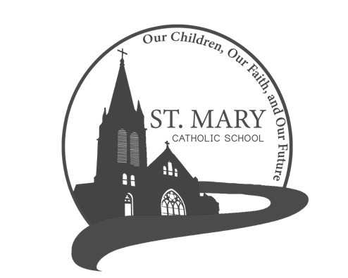
Please spread the word with friends and family, we will host a Kindergarten Round-up on Wednesday May 11th at 6:30 pm in the K Room. Thursday, May 12th will be a day for all new prospects to shadow a kindergartener for part or the whole day!

